# Learning Outcome

# After completing this module, the student should be able to understand Skills on Managing application with serverless compute, DevOps and API management Services (50 Hrs)

To meet the learning outcome, a student has to complete the following activities

1. Analyze your web app on migration tools and develop strategy of migration
2. Create DevOps toolchain for cloud foundry application and enable CI/CD

# Activity 1

## Aim: Analyze your web app on migration tools and develop strategy of migration

**Learning outcome:** Able to understand Skills on Managing application with serverless compute, DevOps and API management Services(50 Hrs)

**Duration:** 5 hour

**List of Hardware/Software requirements:**

1. IBM Cloud Account
2. Websphere server/profile
3. Download Migration Analysis tools

**Code/Program/Procedure (with comments):**

Download and install the WebSphere Liberty V22.0.0.5 packages for windows: [Click here to download](https://developer.ibm.com/wasdev/downloads/liberty-profile-using-non-eclipse-environments/)

Click on download options->HTTPS

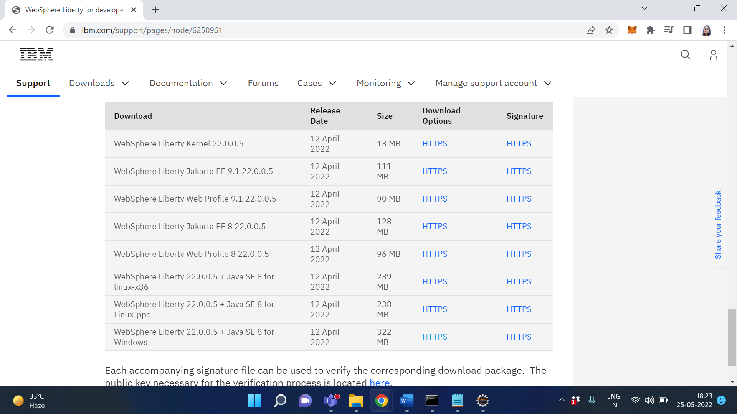

Then Unzip the folder

Download the packages [Migration Toolkit for Application Binaries](https://www14.software.ibm.com/cgi-bin/weblap/lap.pl?popup=Y&la_formnum=&li_formnum=L-DCHS-CBVRRX&title=Software%20License%20Agreement&accepted_url=https://public.dhe.ibm.com/ibmdl/export/pub/software/websphere/wasdev/downloads/wamt/ApplicationBinaryTP/binaryAppScannerInstaller.jar&declined_url=https://www.ibm.com/support/pages/node/6250913)

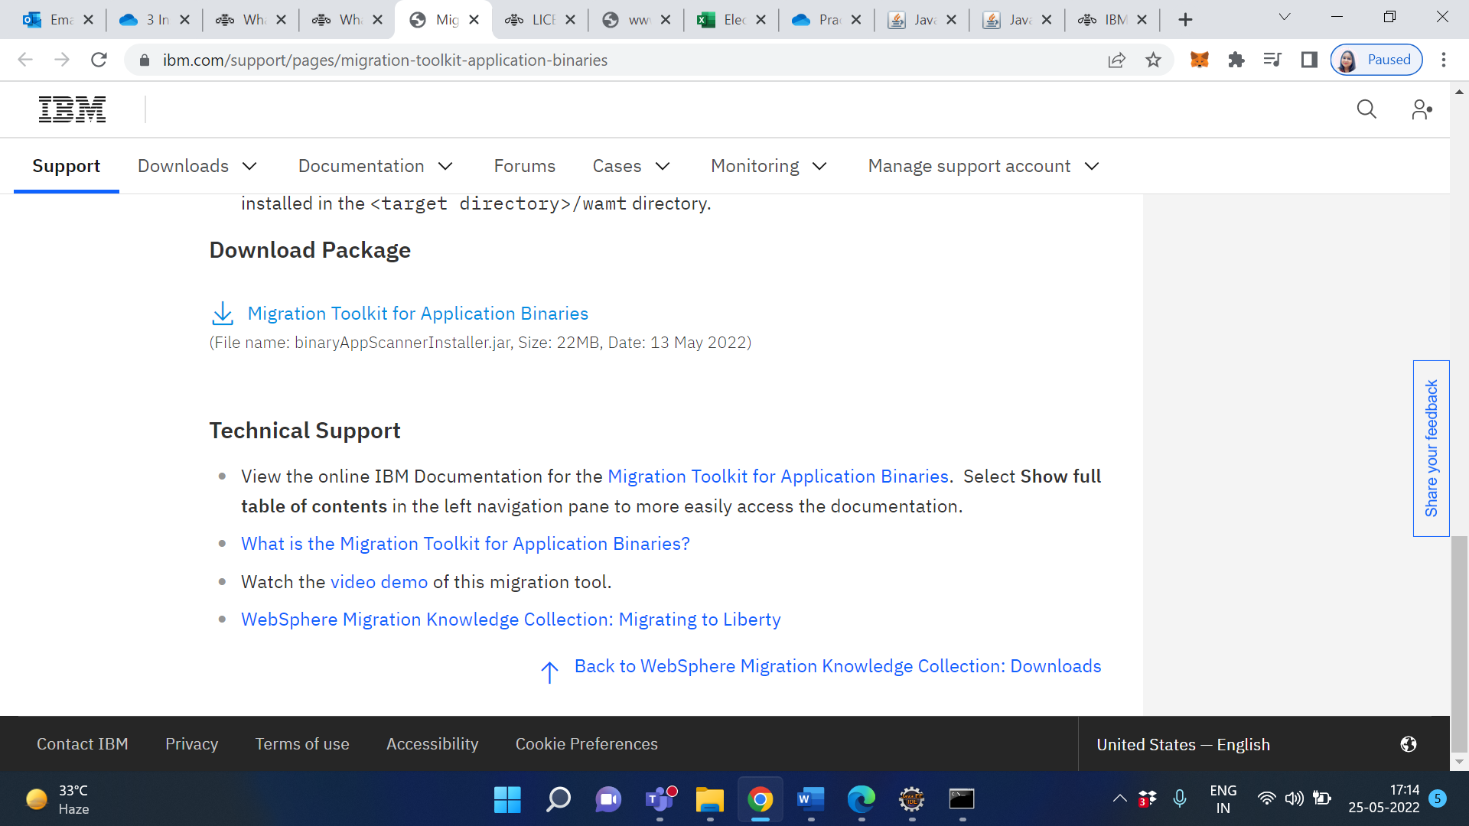

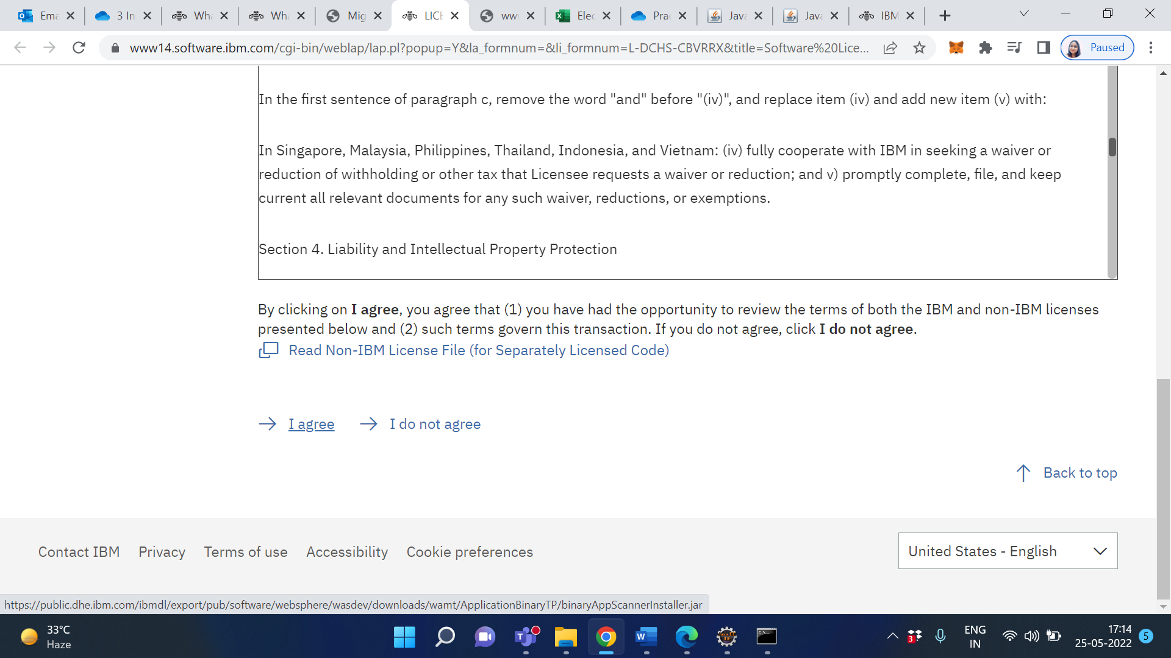

Click on I agree

Copy your downloaded Migration Toolkit for Application Binaries .jar file in any

Folder

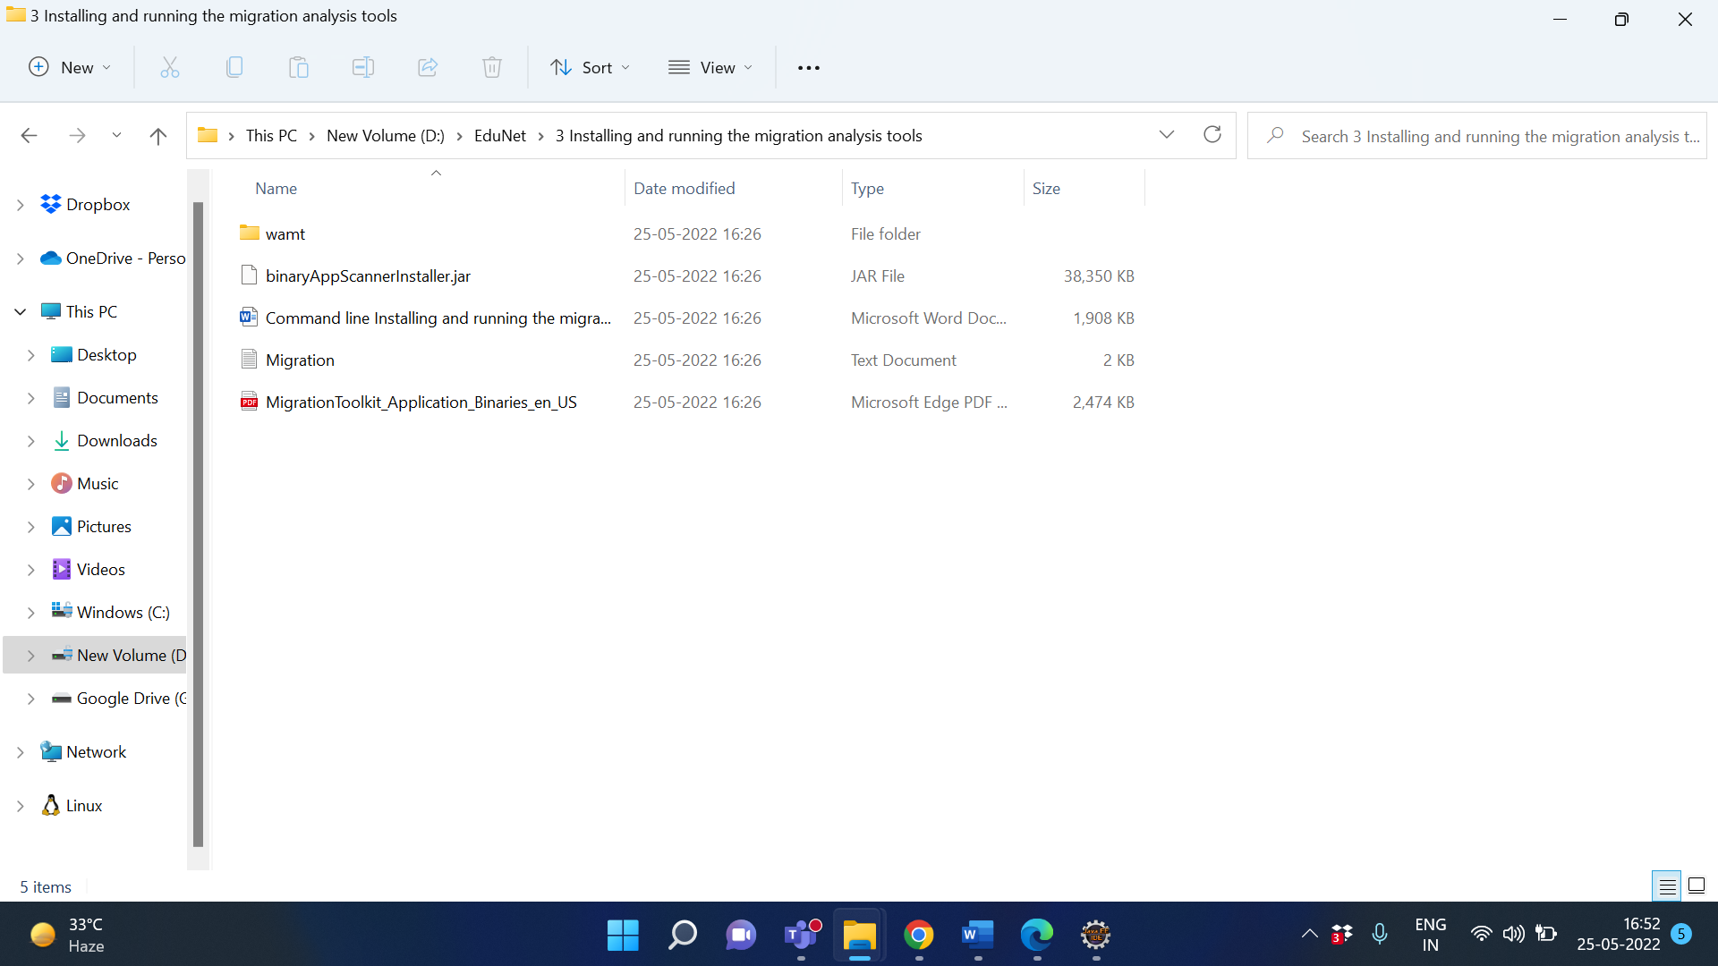

Open Command line and change the directory->Installing and running the migration analysis tools

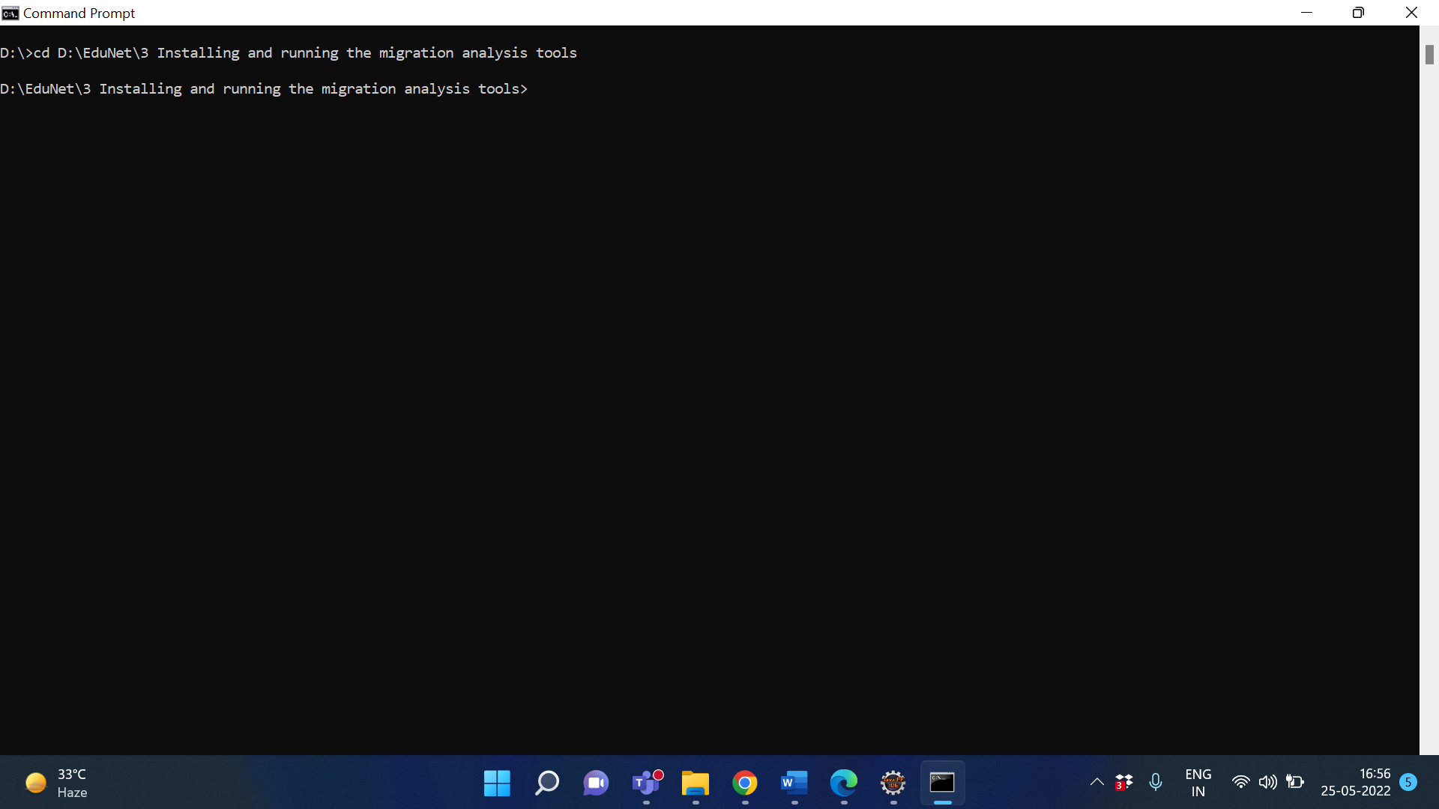

Run the following command and follow the prompts to install the tool:

java -jar binaryAppScannerInstaller.jar

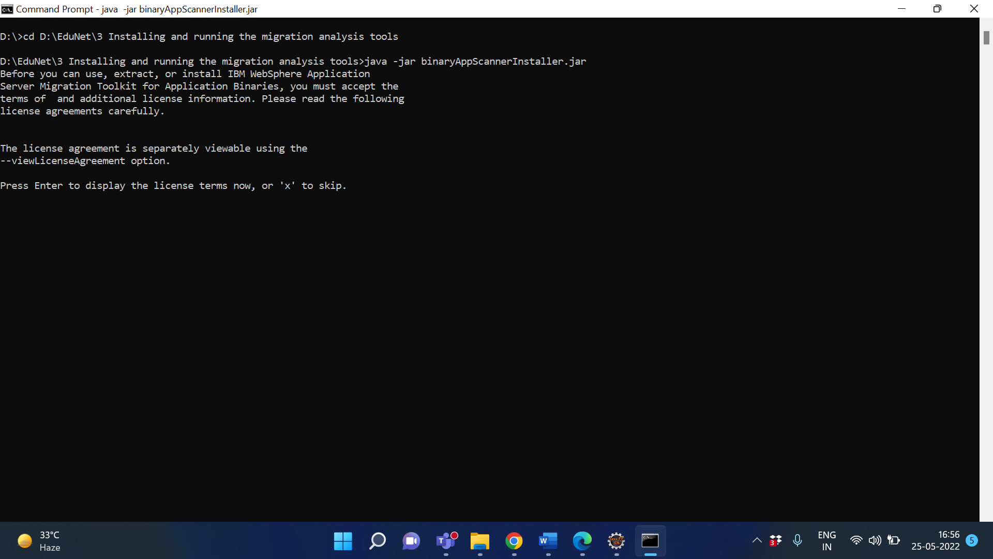

Type X

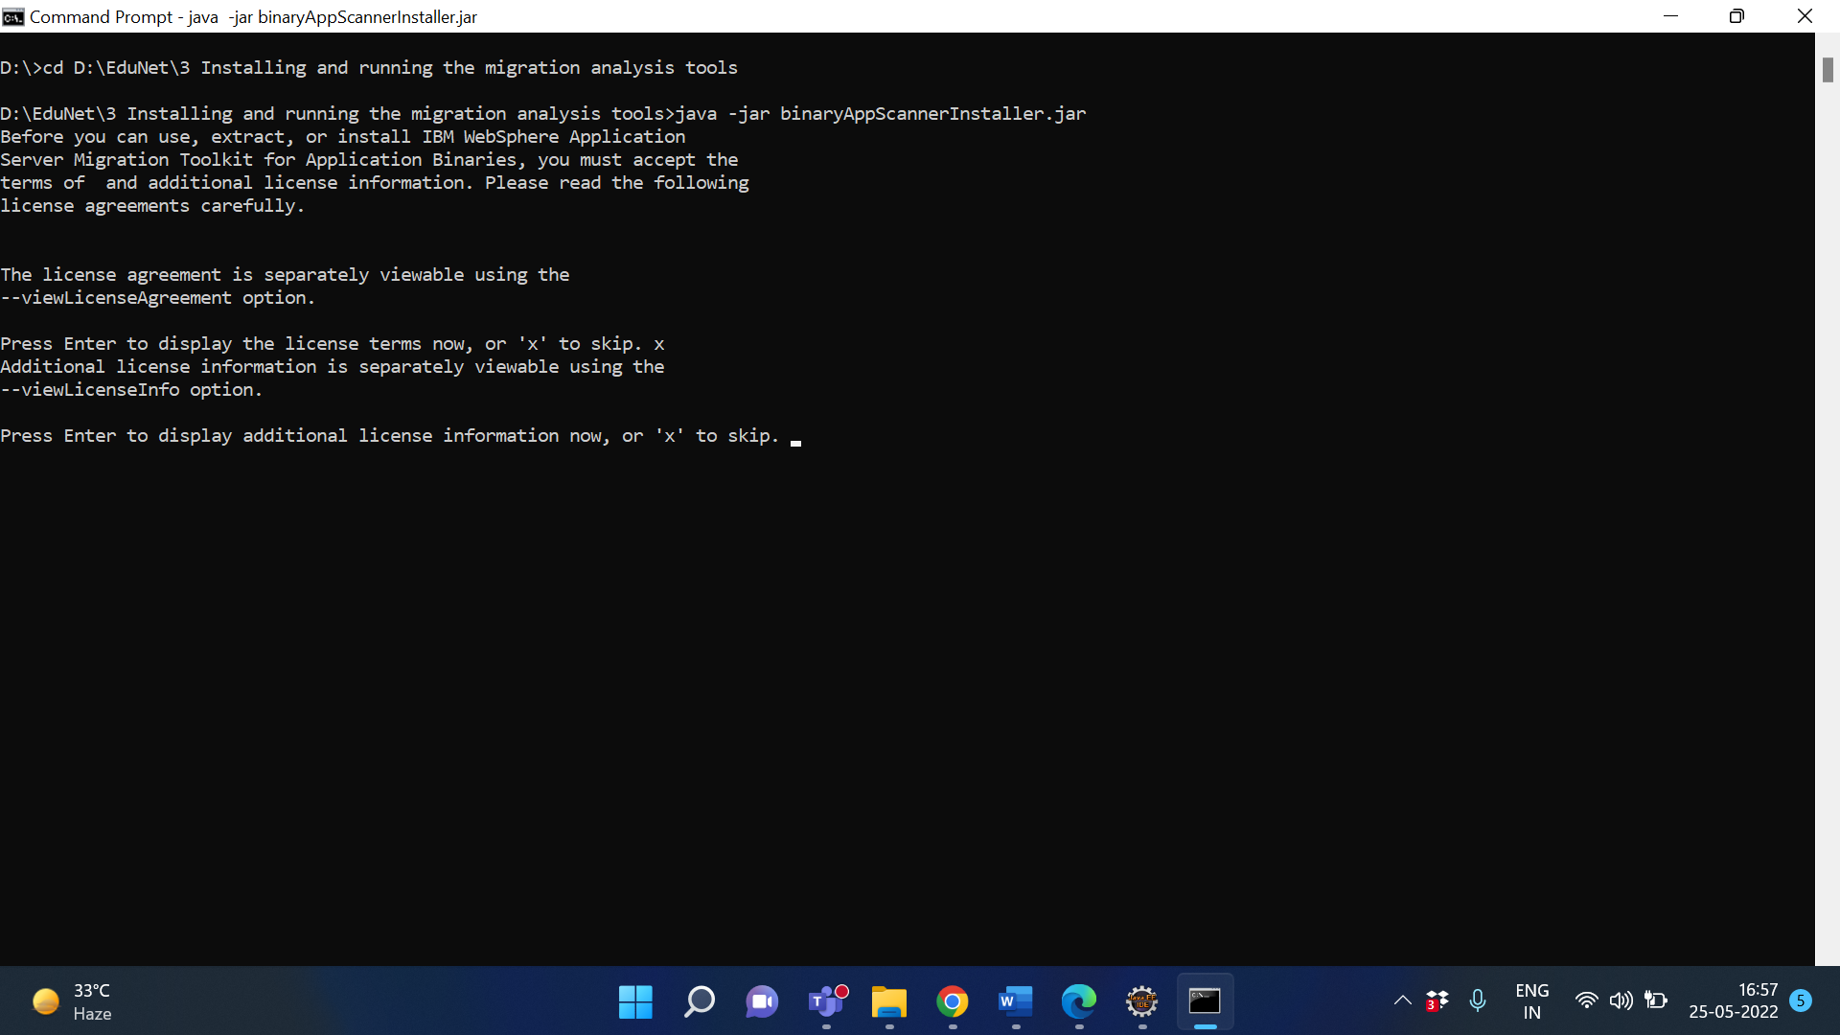

Again type X



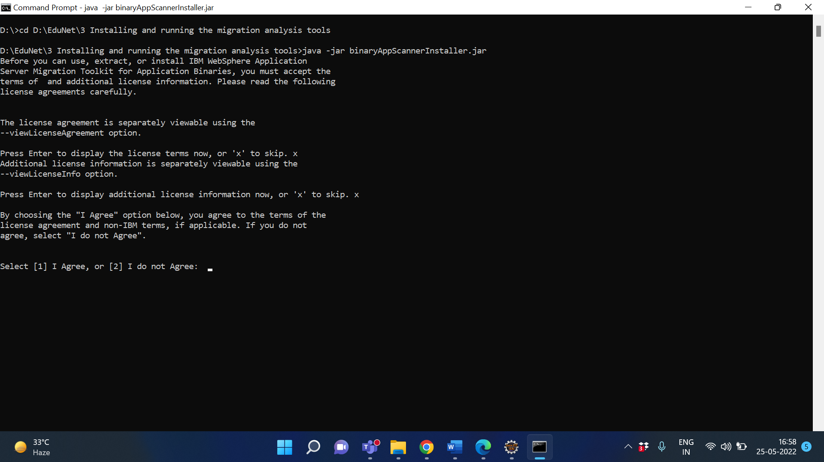

Type 1

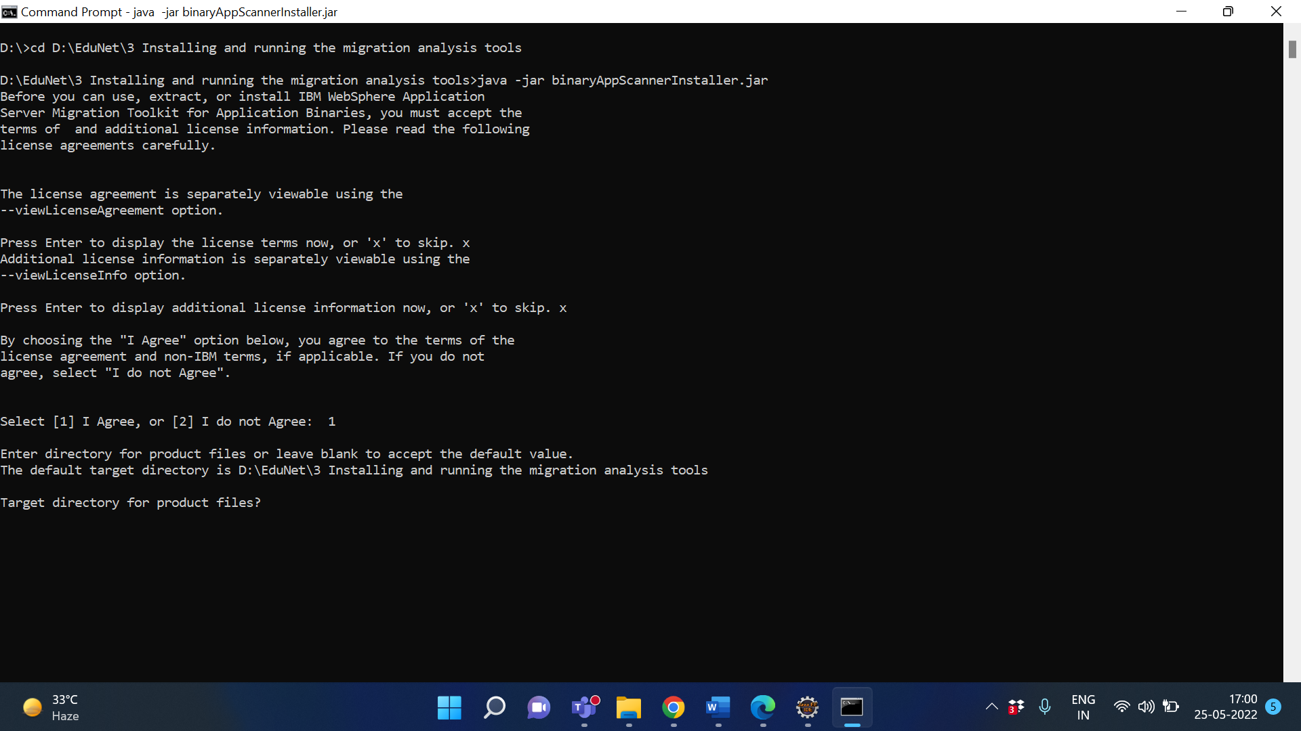

Press Enter to extract files in same directory or you can give different directory

location

Wamt directory is created in same directory

Type cd wamt

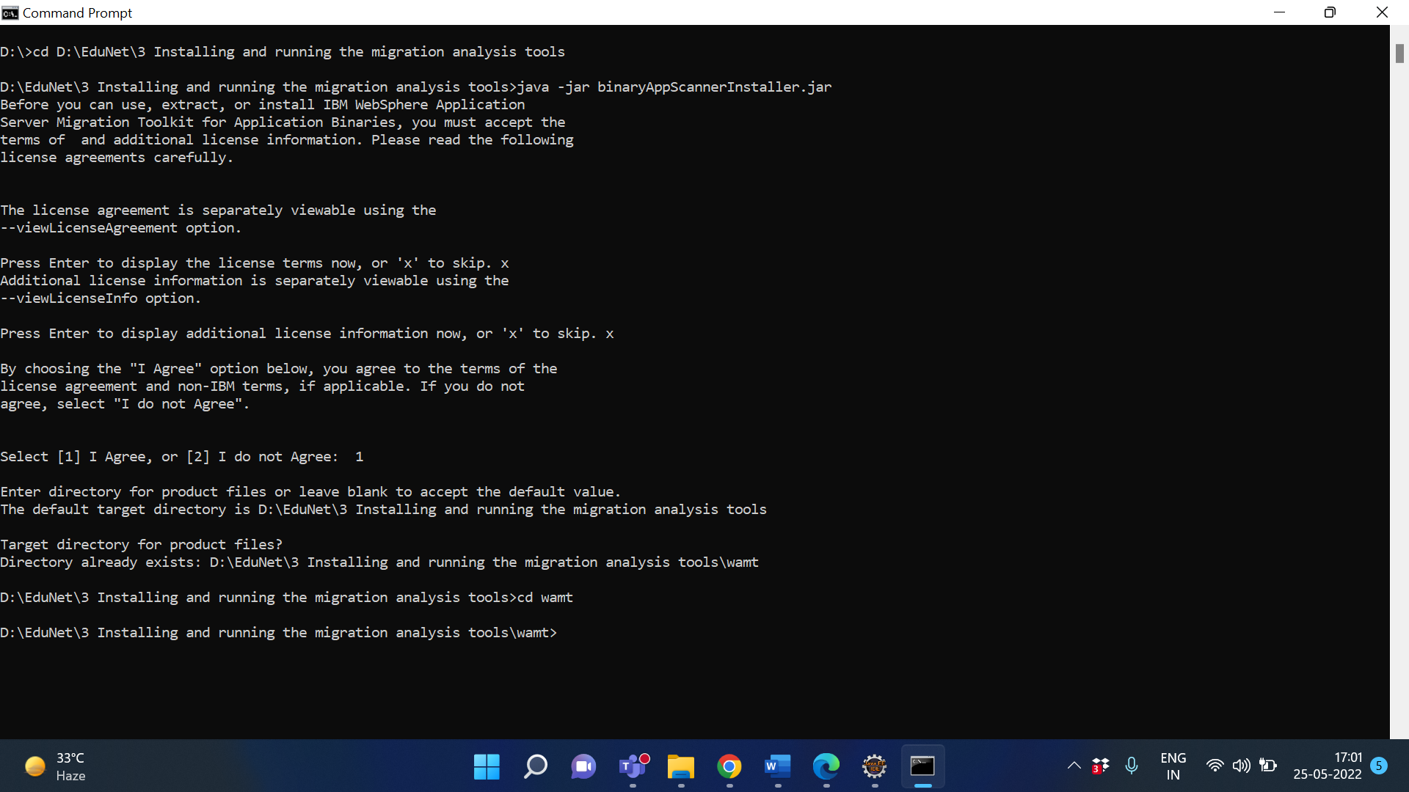

Type: java -jar binaryAppScannerInstaller.jar --help –analyze

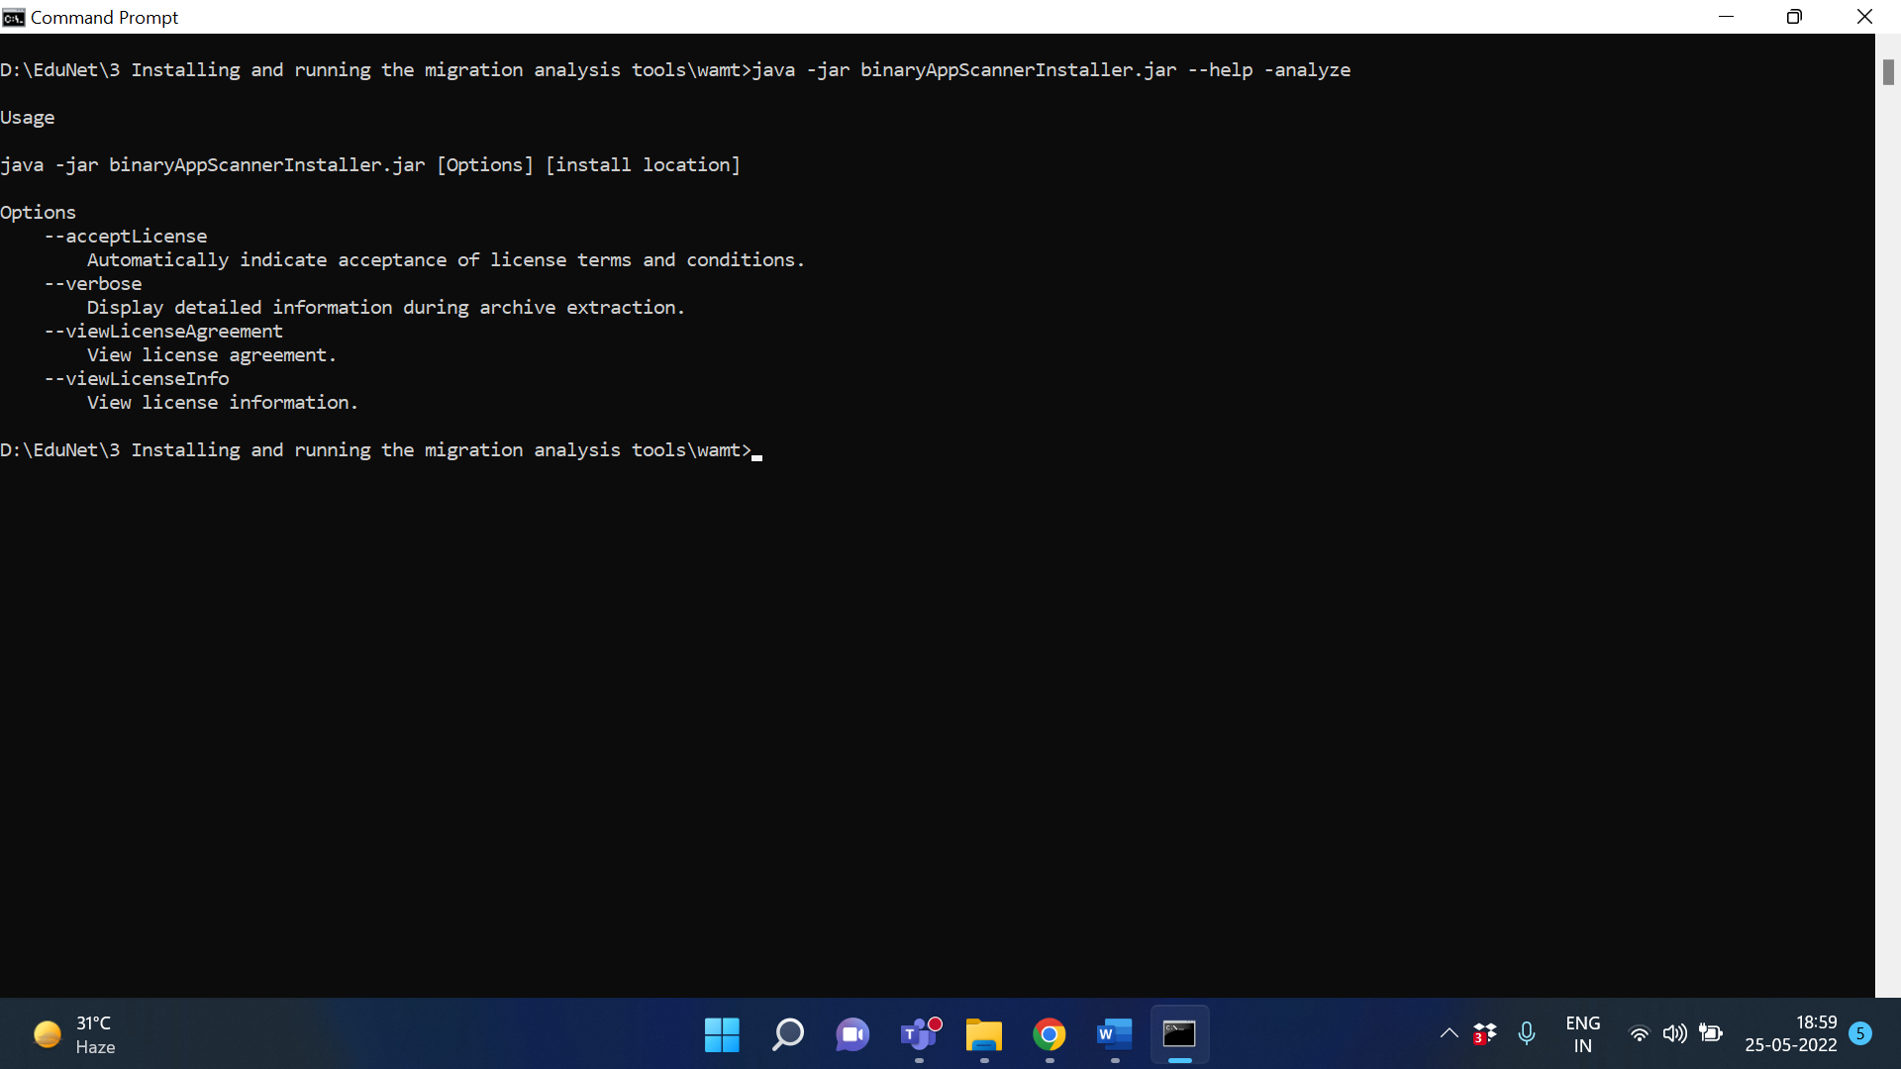

To display the default report, an HTML report for a migration from WebSphere Application Server

traditional V8.5.5 to Liberty, run the following command:

Format

java -jar binaryAppScanner.jar binaryInputPath --analyze

Example

java -jar binaryAppScanner.jar binary D:\EduNet\wlp --analyze

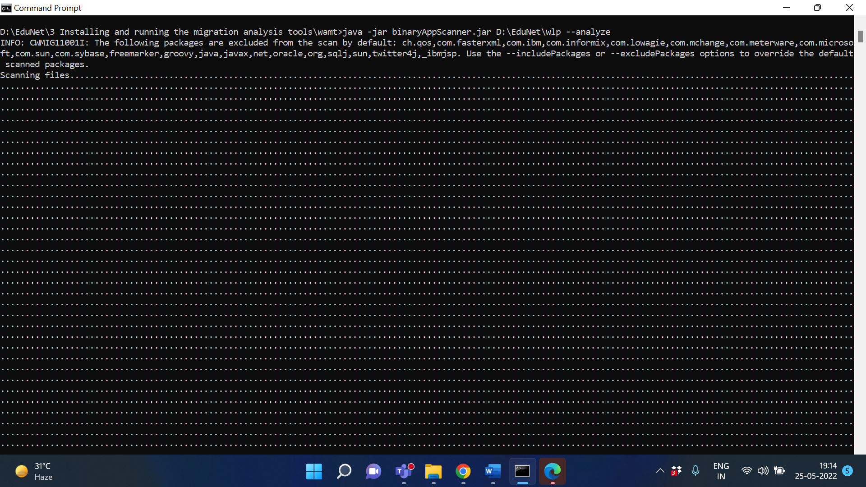

Wait 2-5 minutes

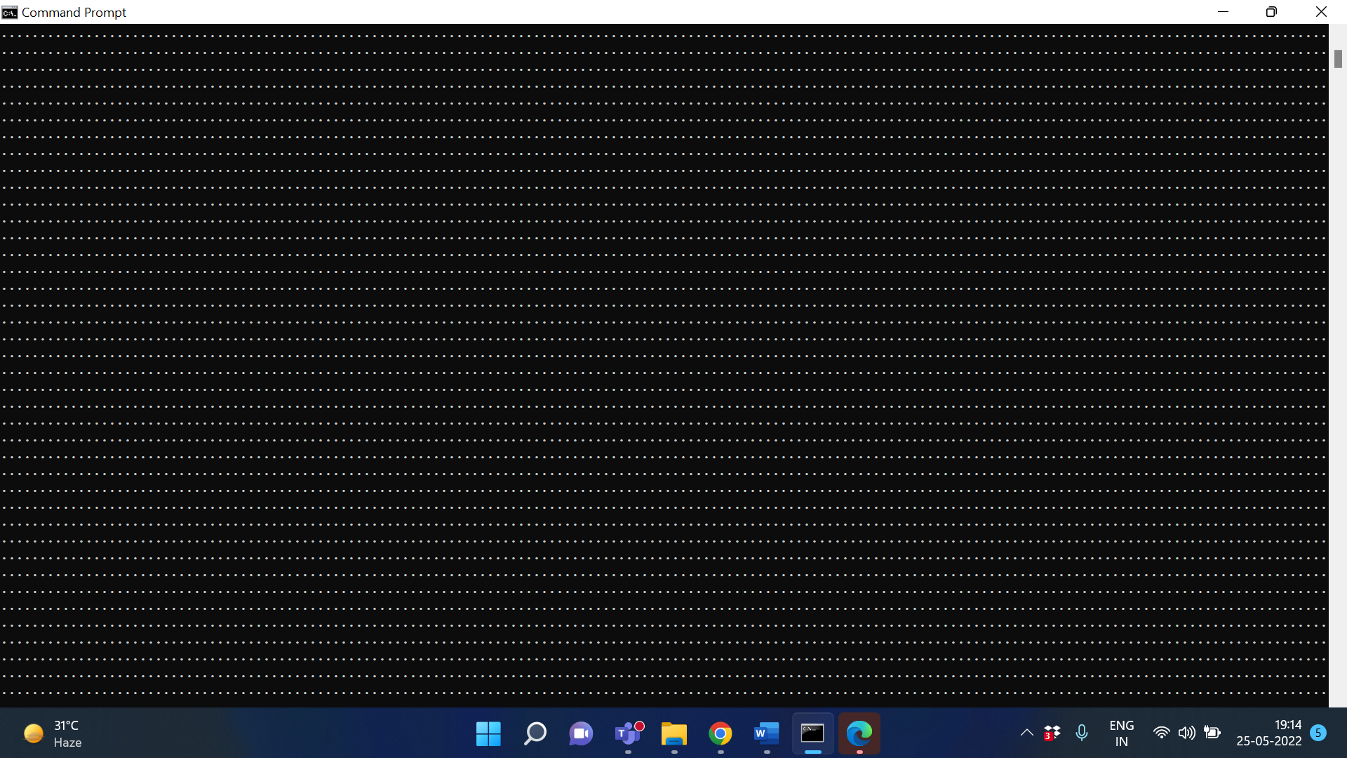

**Output/Results snippet:**

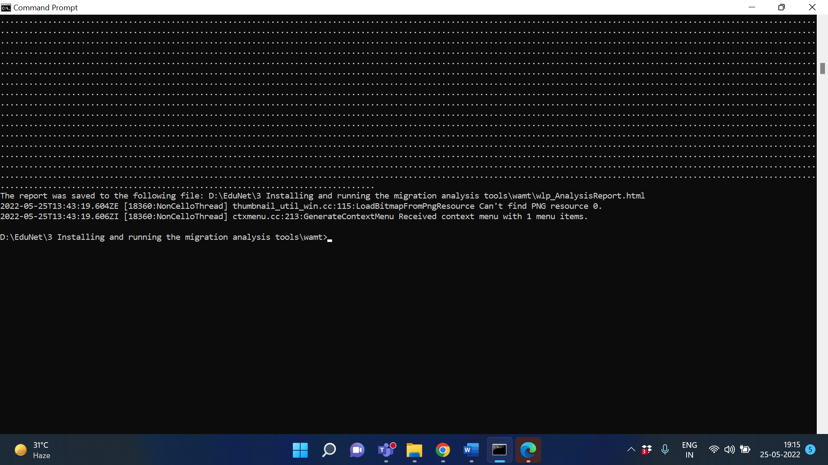

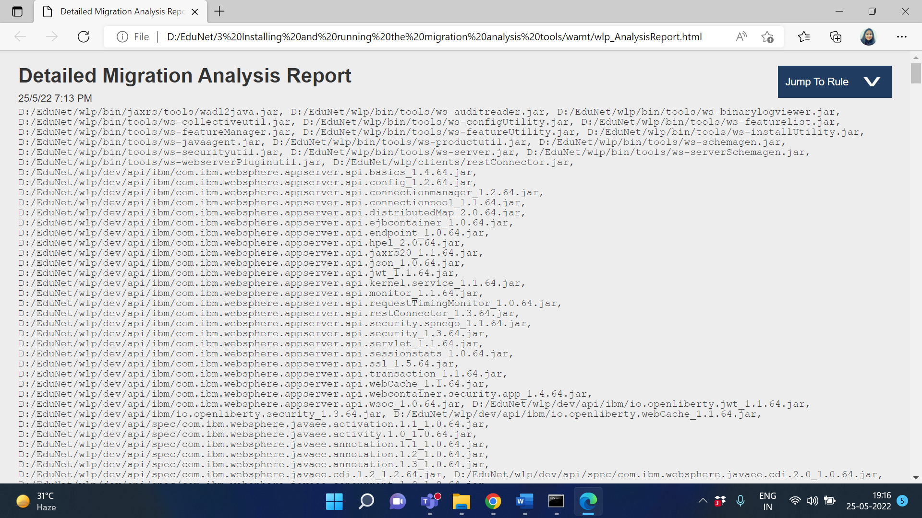

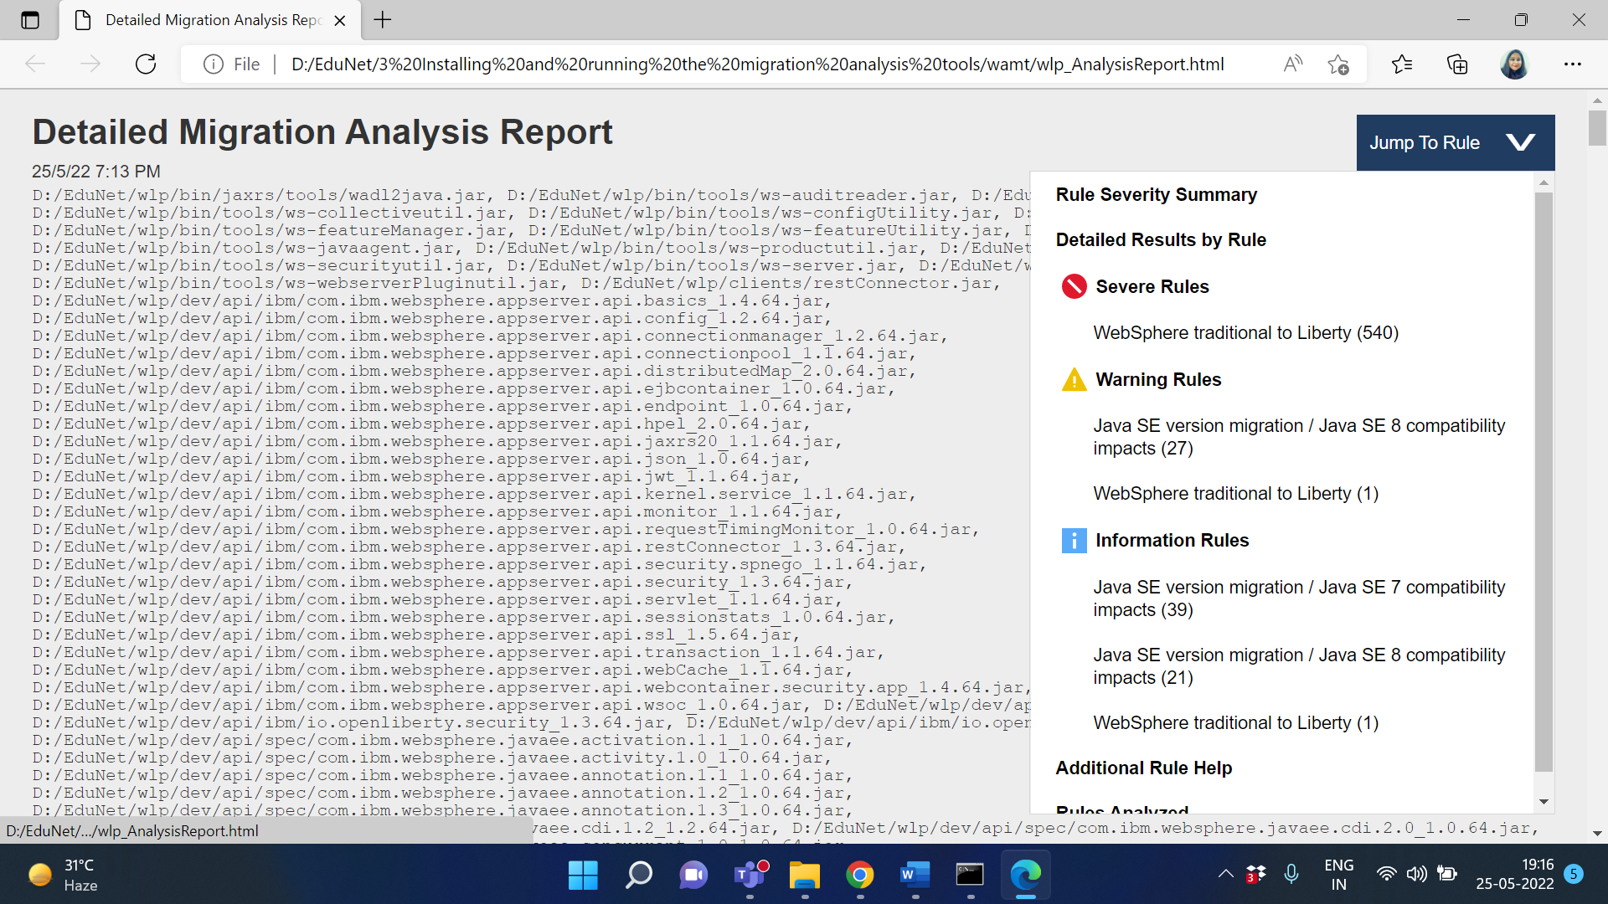

**Example 2**

To create a JSON-formatted report file with the default name of MyAppDir_AnalysisReport.json

in the current directory where binaryInputPath is set to /MyAppDir, run the following command:

java -jar binaryAppScanner.jar D:\EduNet\wlp --analyze --format=json

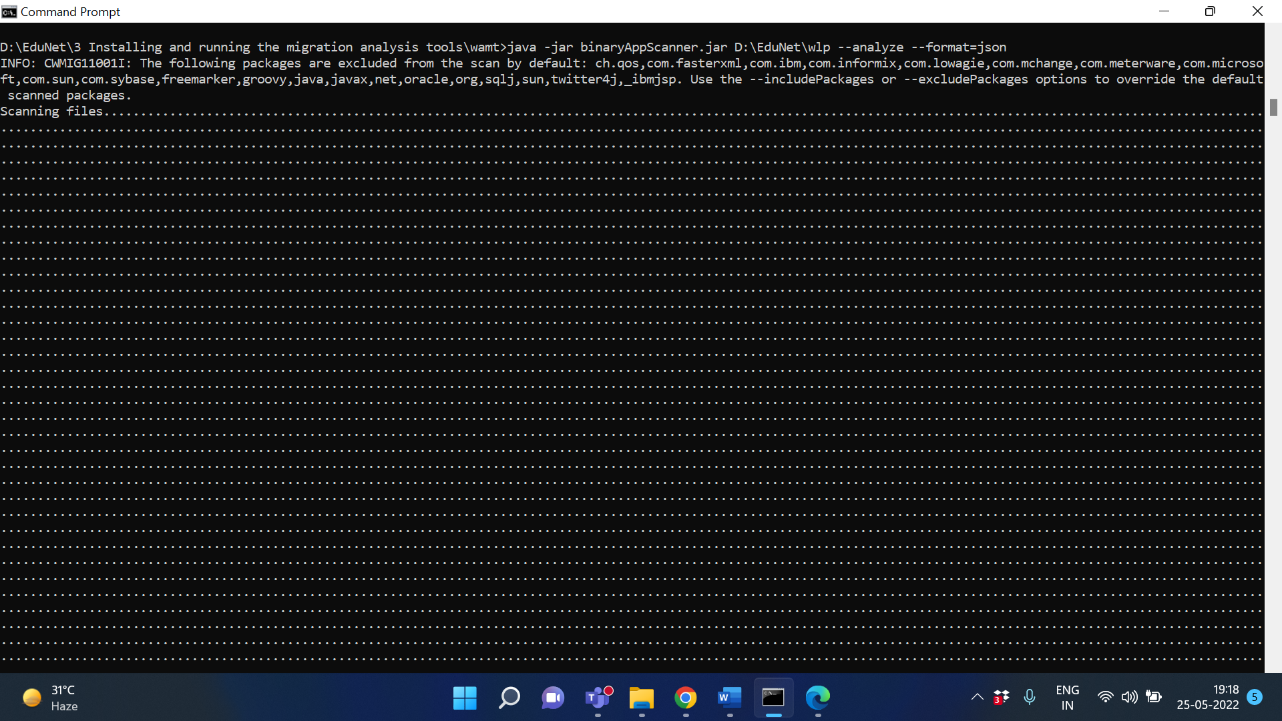

**OUTPUT**

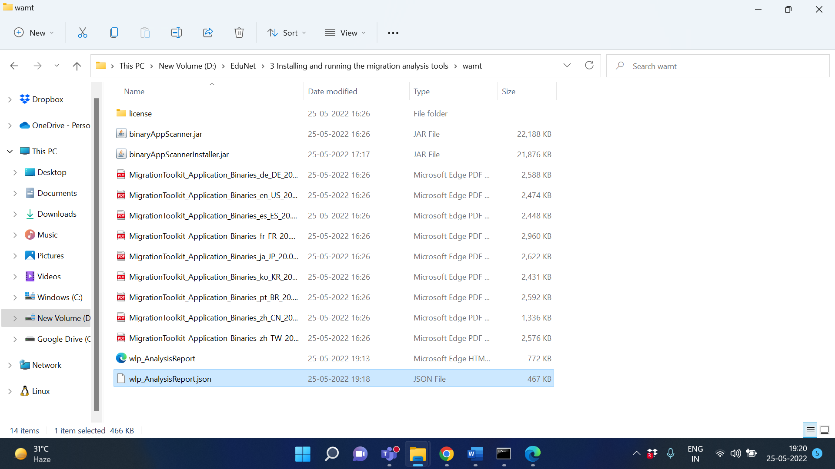

.json file created in directory

wlp_AnalysisReport.json

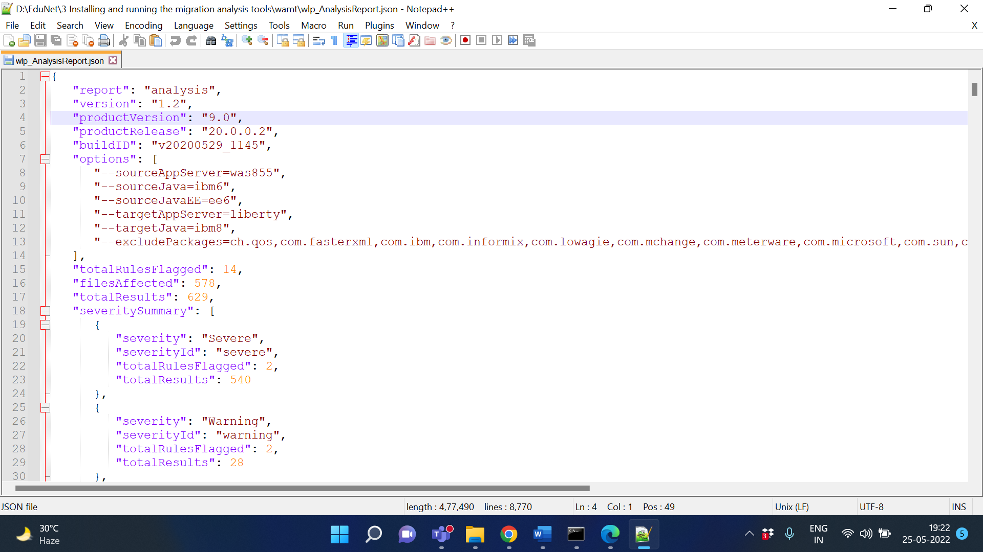

**References:**

* <https://developer.ibm.com/wasdev/downloads/liberty-profile-using-non-eclipse-environments/>
* <https://developer.ibm.com/wasdev/downloads/#asset/tools-Migration_Toolkit_for_Application_Binaries>

# Activity 2

## Aim: Create DevOps toolchain for cloud foundry application and enable CI/CD

**Learning outcome:** Able to understand Skills on Managing application with serverless compute, DevOps and API management Services(50 Hrs)

**Duration:** 5 hour

**List of Hardware/Software requirements:**

1. IBM Cloud Lite account - sign up here
2. GitHub account

**Code/Program/Procedure (with comments):**

**Push this code into the GitHub repository:** [**Repository Link**](https://github.com/Deepika25-create/go-app-cicd-demo-main.git)

Let's get this code into GitHub.. Don't worry it's pretty simple, just follow the following commands:

git add . - this command will add all of the new/modified files into staging ready to be committed.

git commit -m "initial commit" - this command commits the changes ready to be pushed with a message so they can easily be identified.

git push origin main - this will push the changes into the master/main branch - this is fine for an initial commit but going forward you will use feature branches.

**Creating a toolchain**

Login or sign up to IBM Cloud

Navigate to the DevOps section in IBM Cloud using the navigation menu on the left

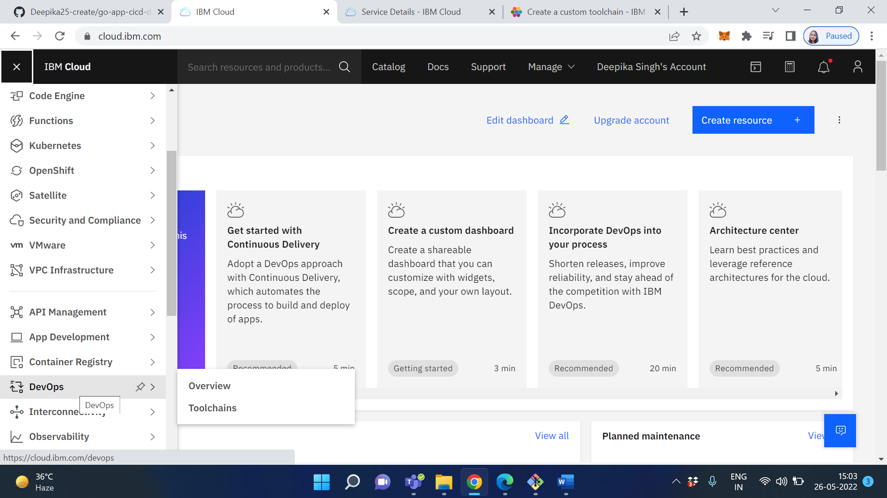

Select your region and then create a new toolchain

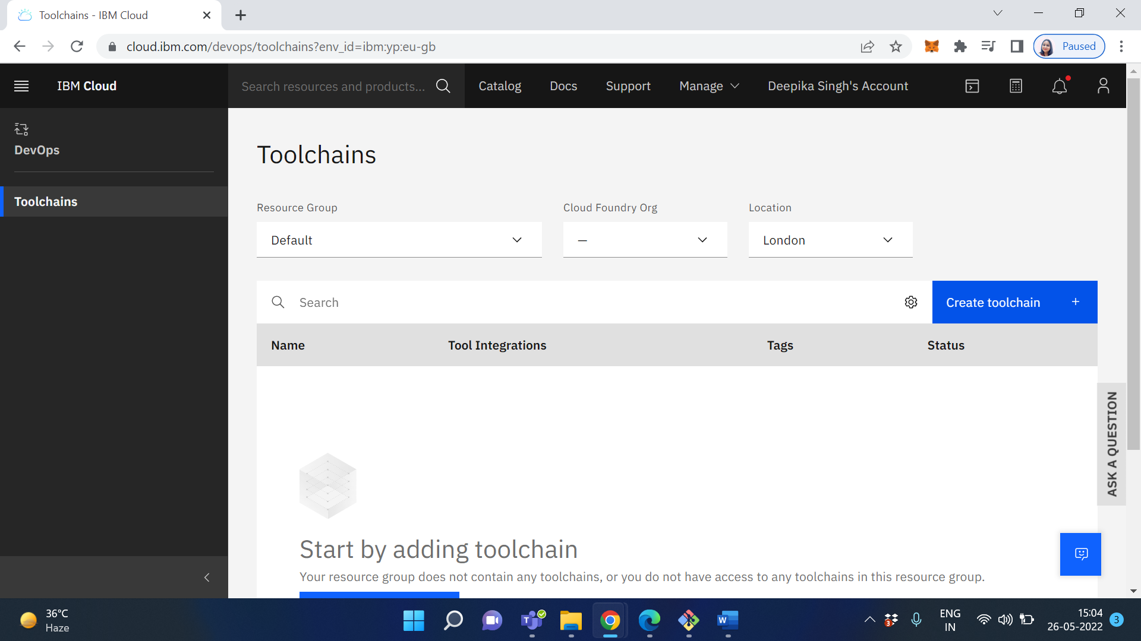

Scroll down to the bottom and select "Build your own toolchain"

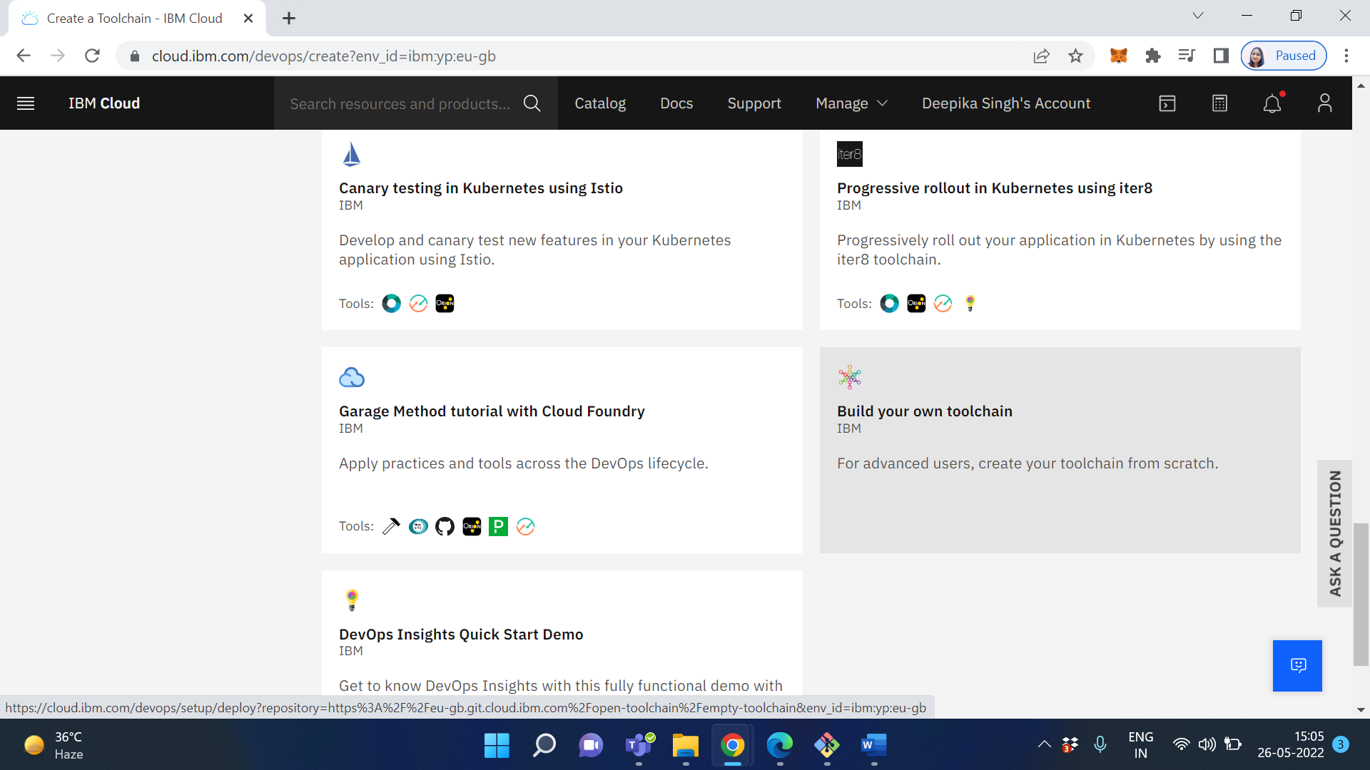

Choose an appropriate name and select the correct region for your toolchain

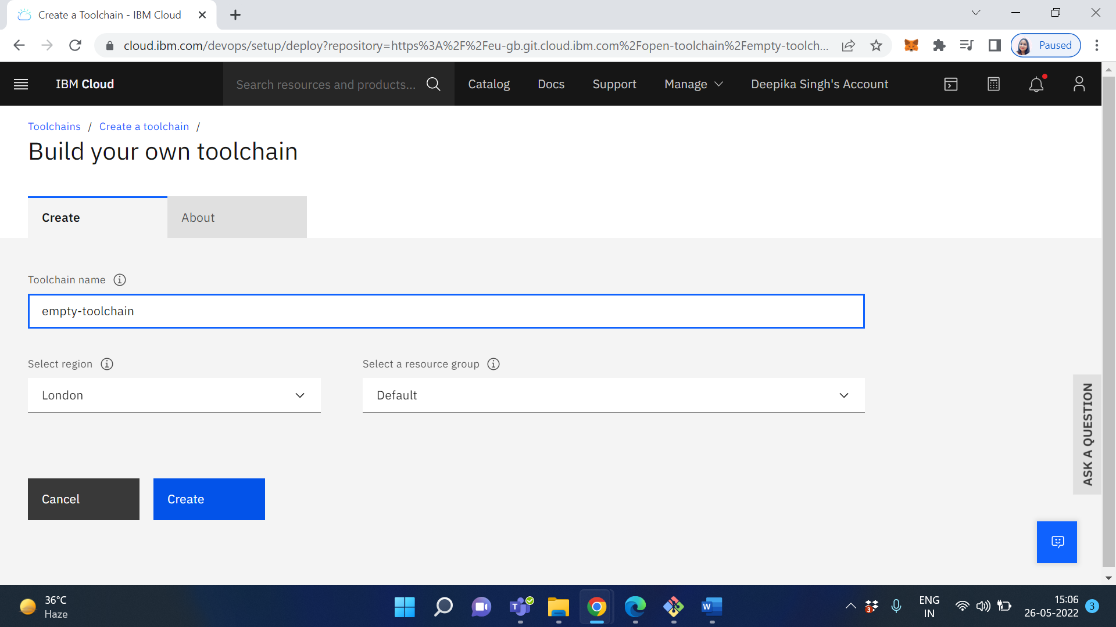

Click on Create

add a new tool to your toolchain

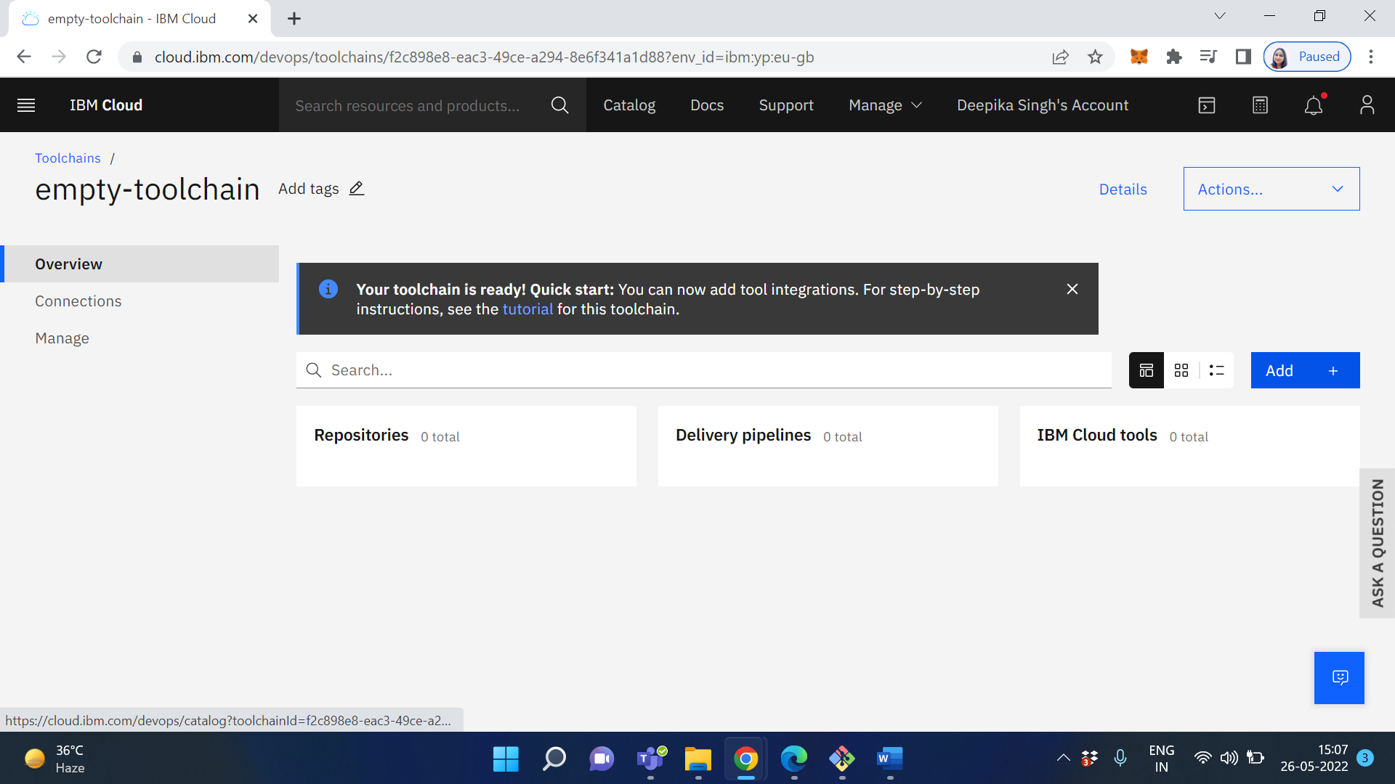

We want to have GitHub integration so search for "GitHub" and select the GitHub tool

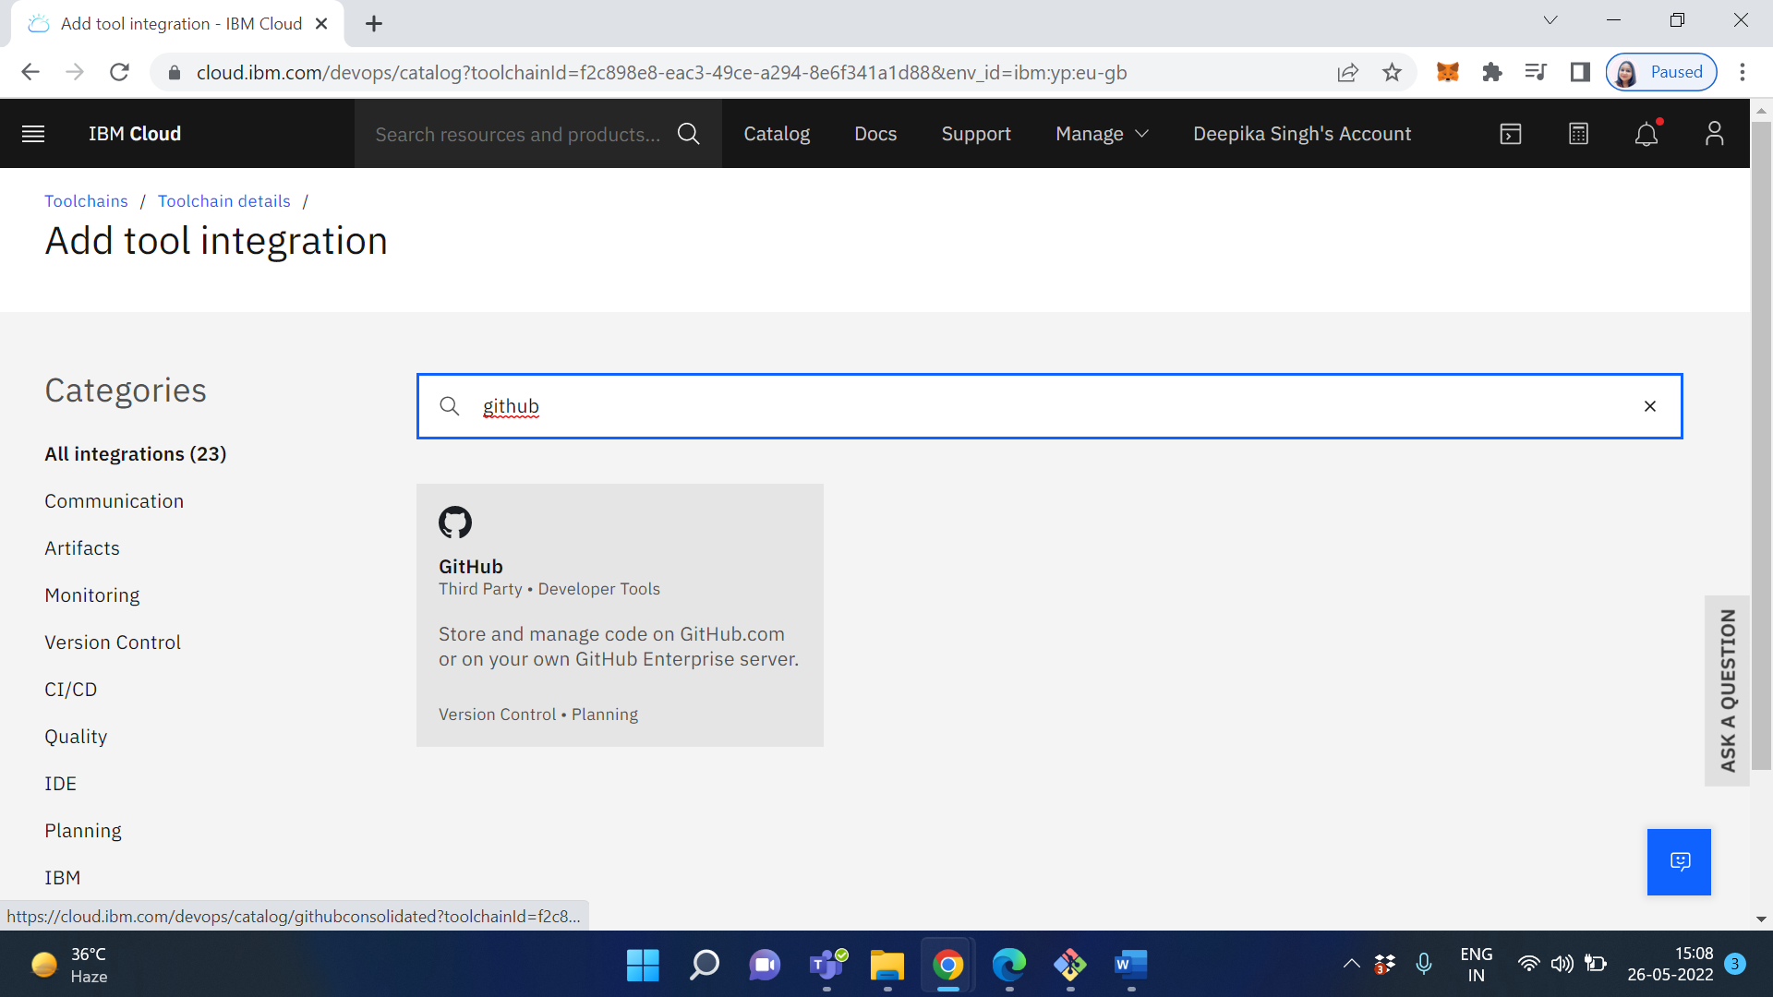

Set up the GitHub tool to have the correct information for your project repository,

Example:

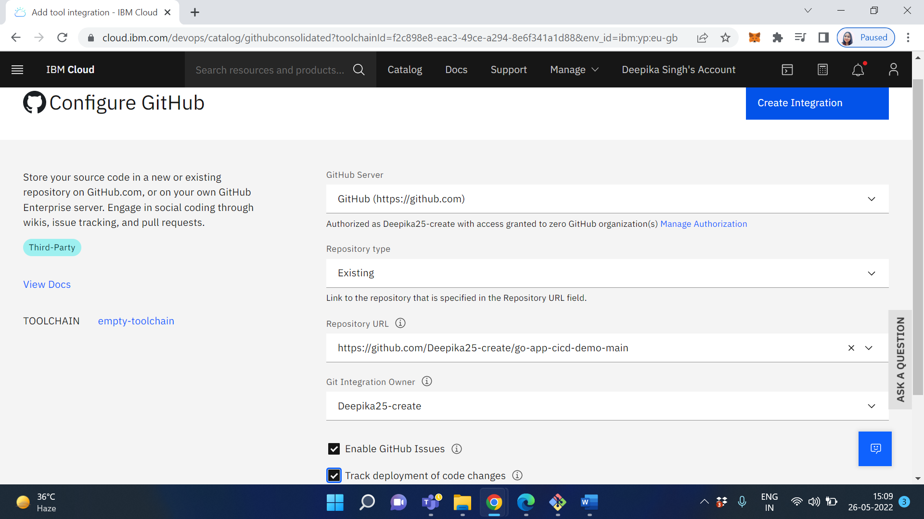

Click on Create Integration

You should now see that the GitHub tool on the toolchain overview has ticks and the word "configured". This will give it access to the repository information (you may be asked to confirm this on GitHub)

Next, you need to add a pipeline. On the toolchain overview, just like you did with the GitHub tool, select "Add tool"

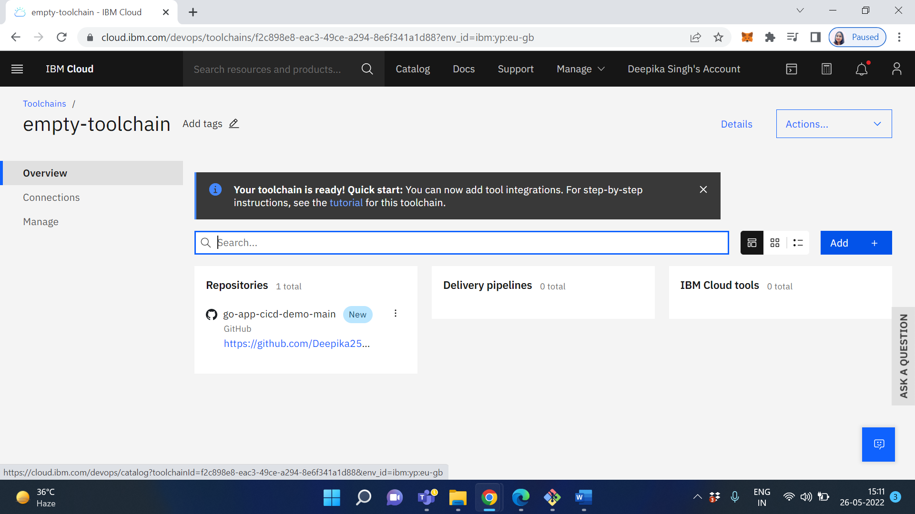

Search for "pipeline". Select "Delivery Pipeline"

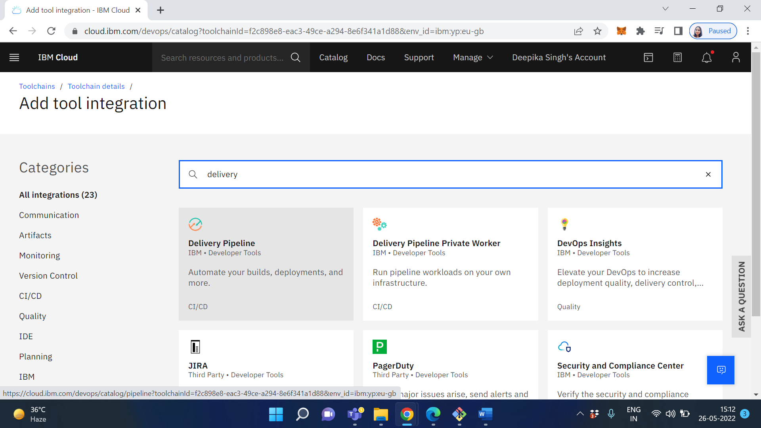

Configure the pipeline by giving it a name and ensuring the pipeline type is "Classic"

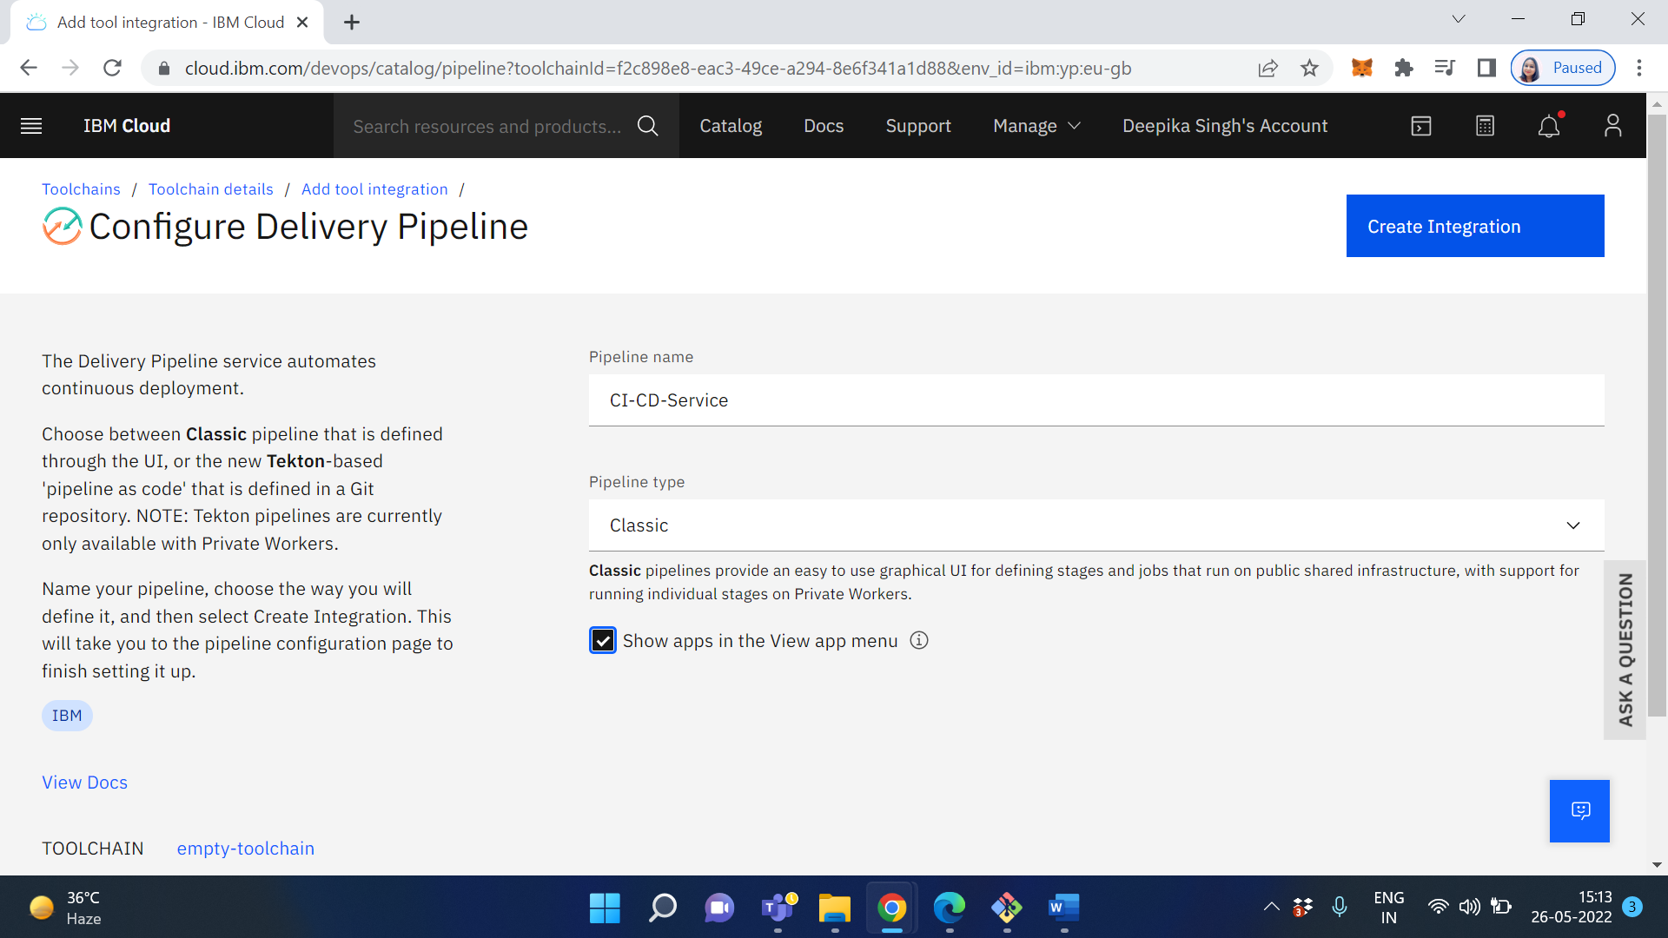

Click on Create Integration

If you haven't used a pipeline in IBM Cloud before, you may see the following error. You just need to add a continuous delivery service which will enable the CI/CD

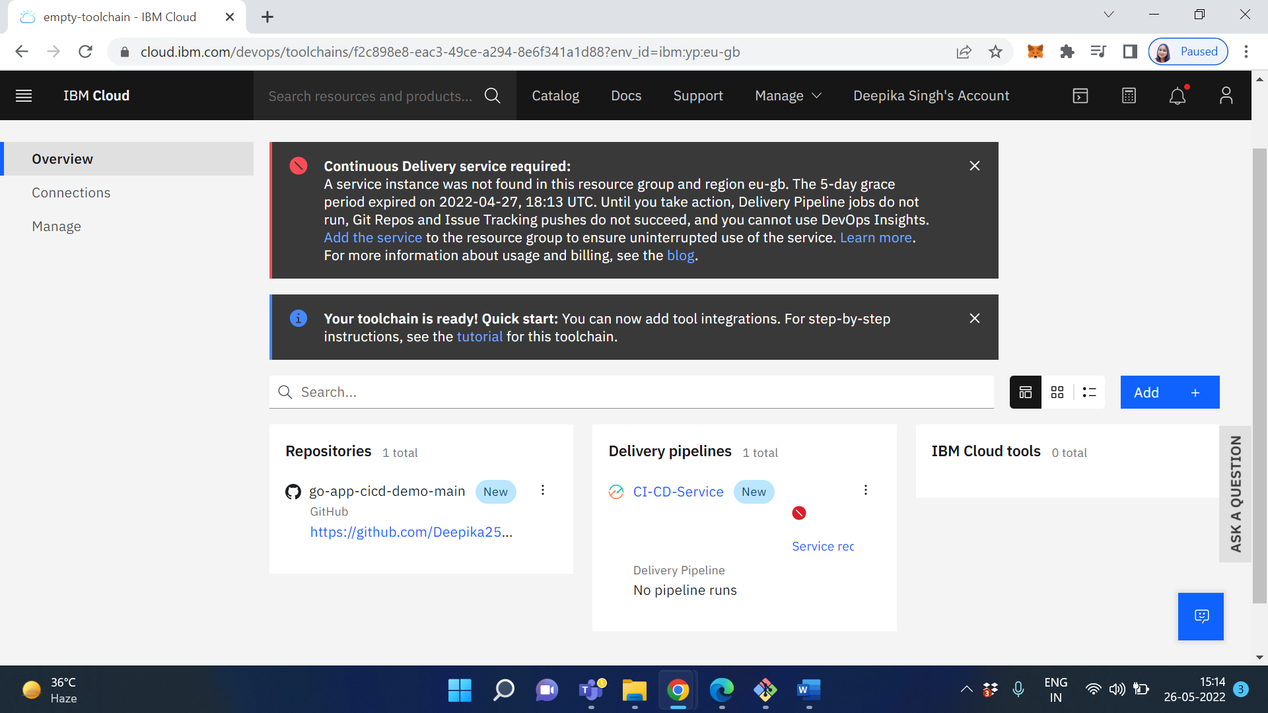

Click on Add the service which is shown in blue color link

Search for continuous delivery and select "Continuous Delivery" - You only need to do this once!

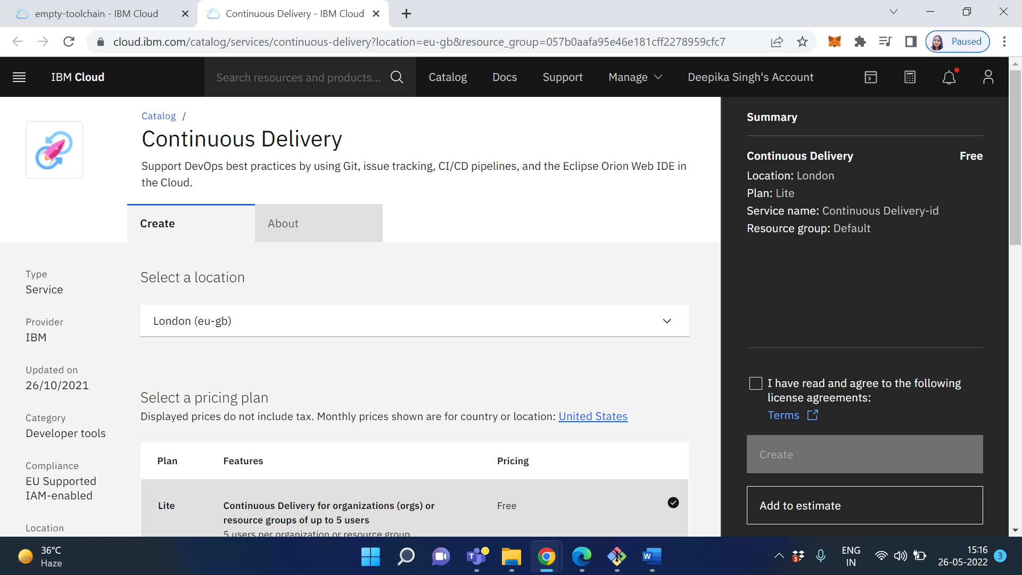

Change the service name as CI-CD-Service

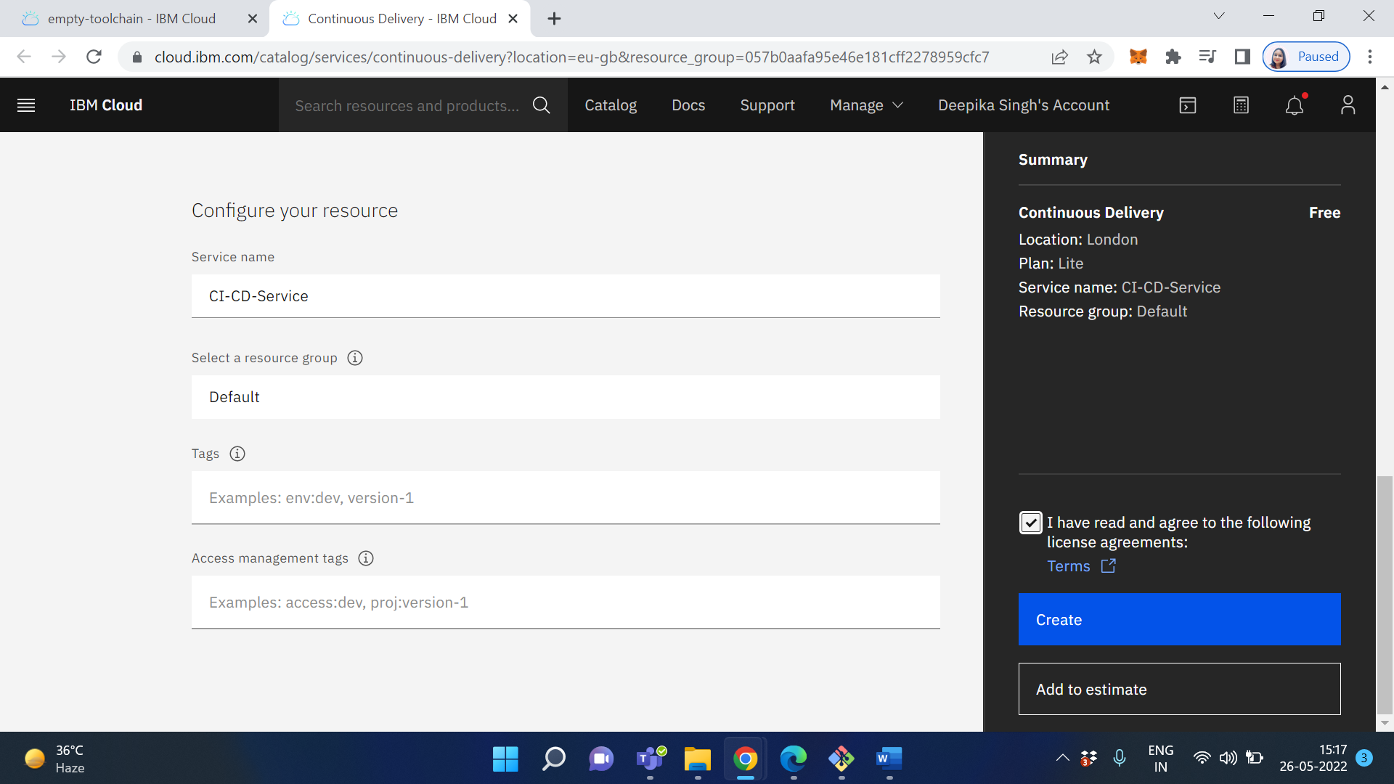

Click on Create

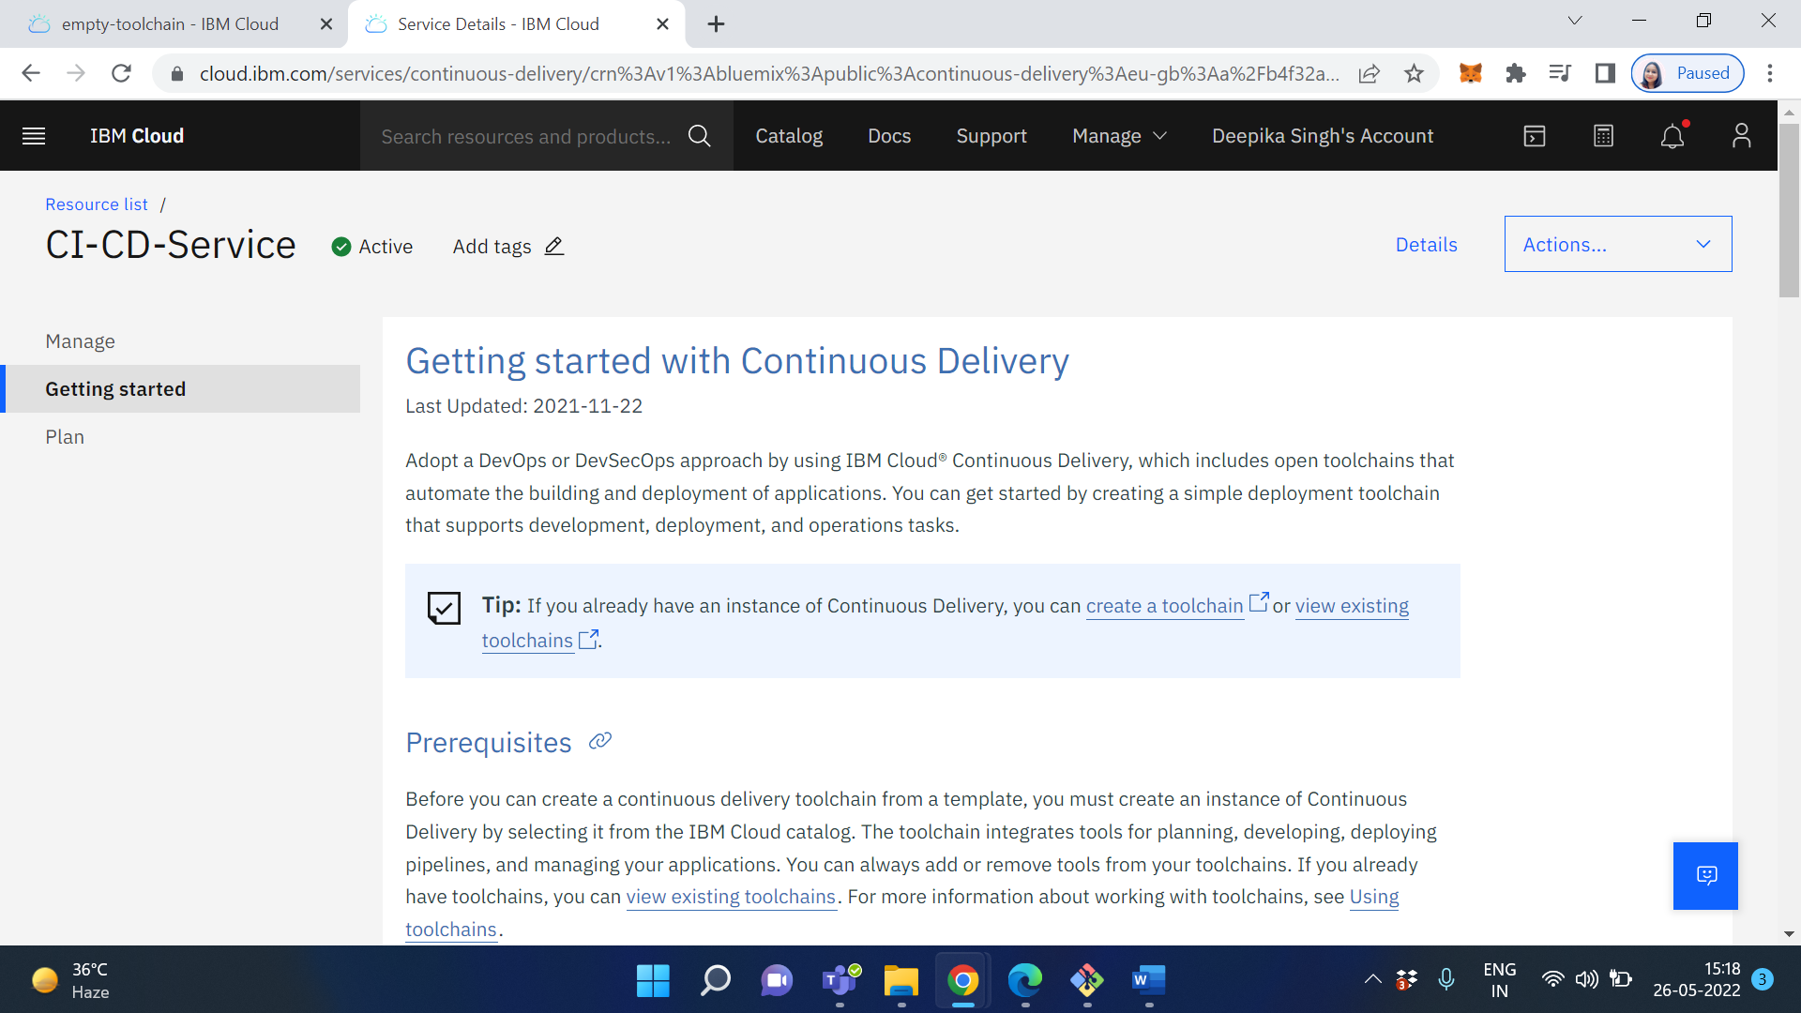

Now head back to your toolchain and click on the Pipeline box itself. You will be taken to a blank page. In the top right select "Add Stage"

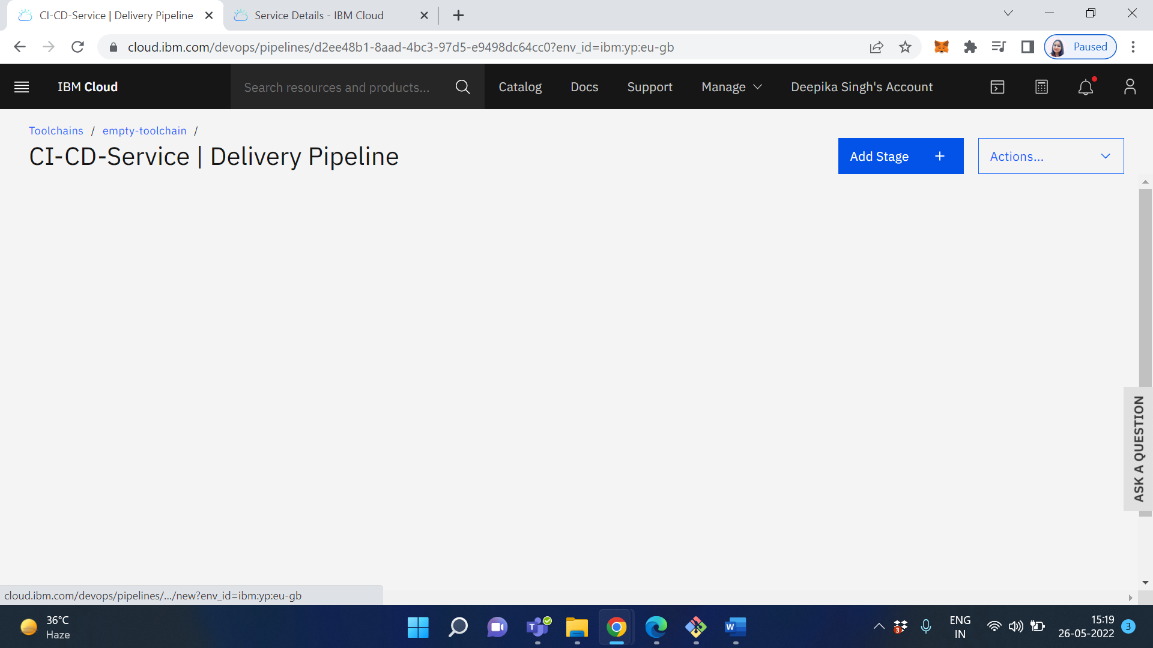

Call it the "Test Stage" and this will build the code and then run the tests. Make sure the input type is the git repository for your project, the branch is set to "main" and you want this stage to run "When a pull request is opened or updated"

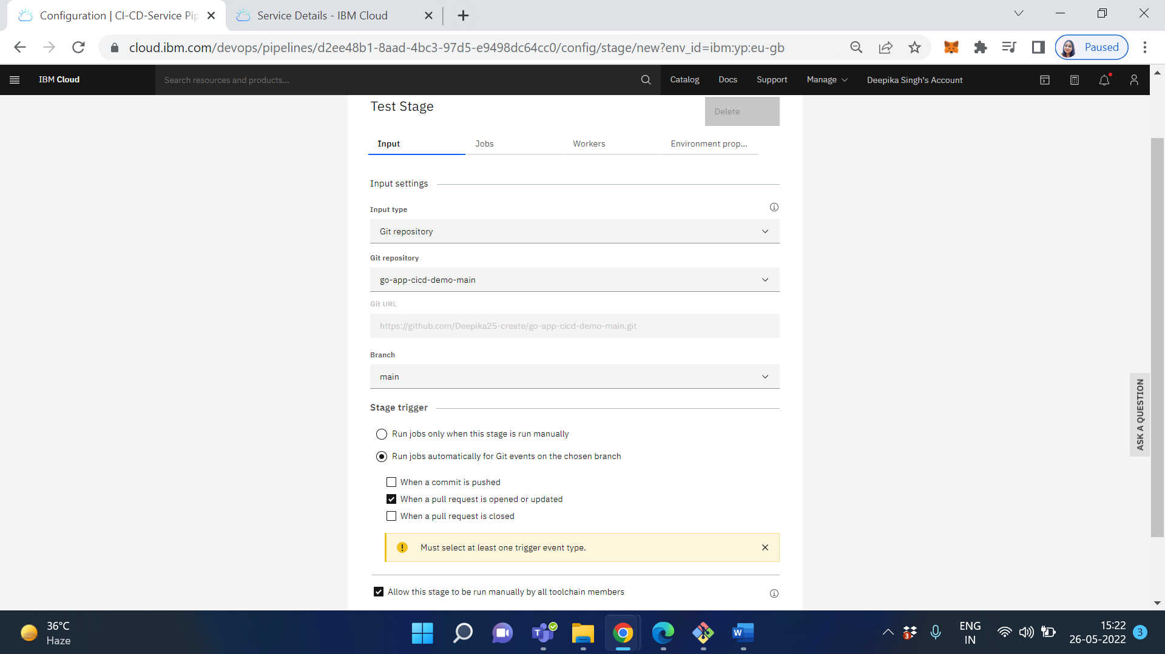

Once the "Input" has been set up, move along to the "Jobs" and create 2 jobs. 1 x Build and 1 x Test. There is no Golang buildpack in the toolchain so we need to use a docker image with the environment set up for us

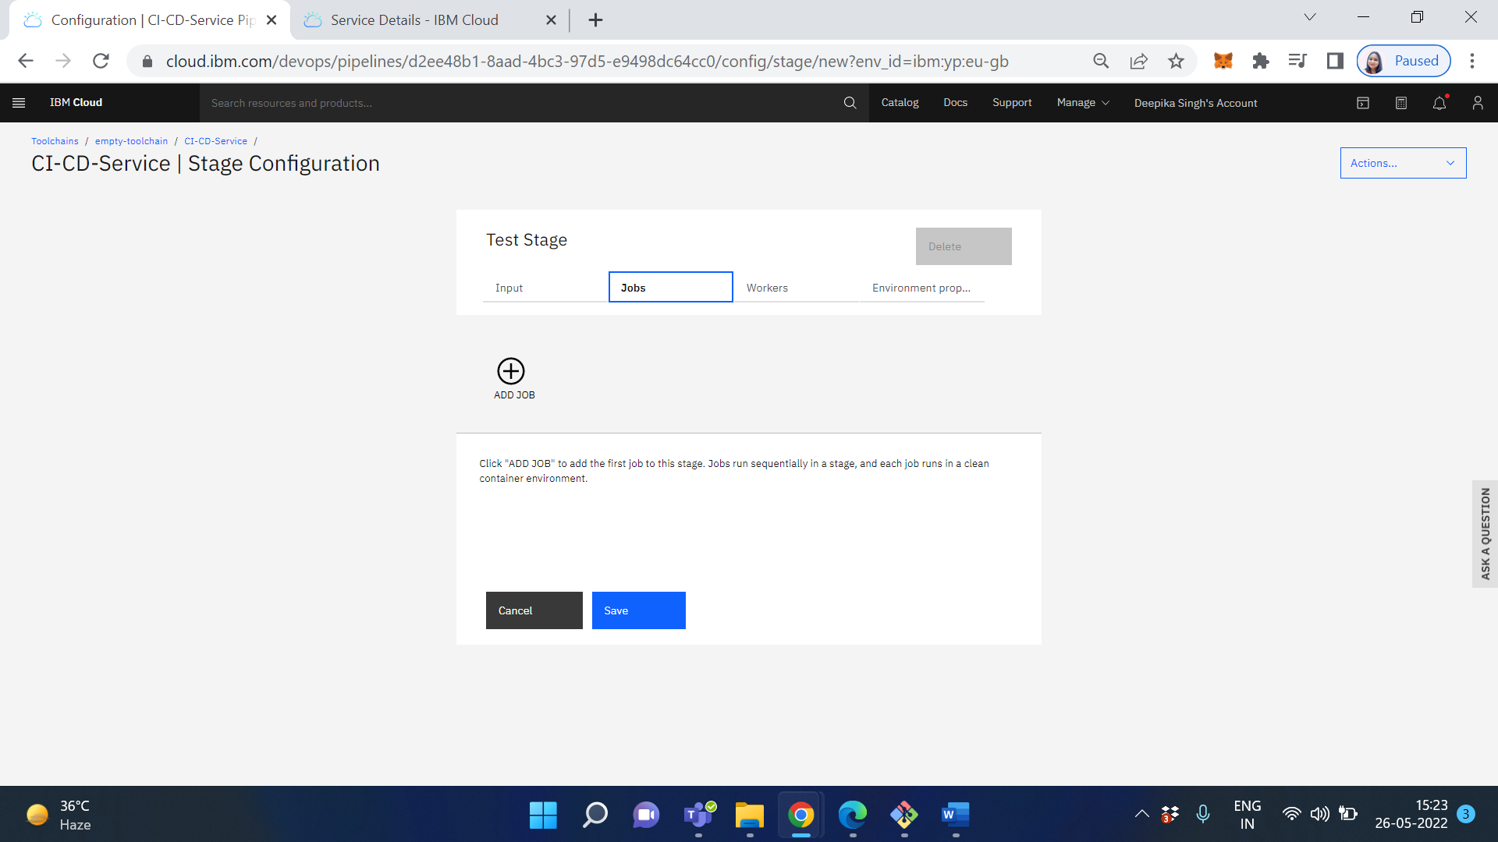

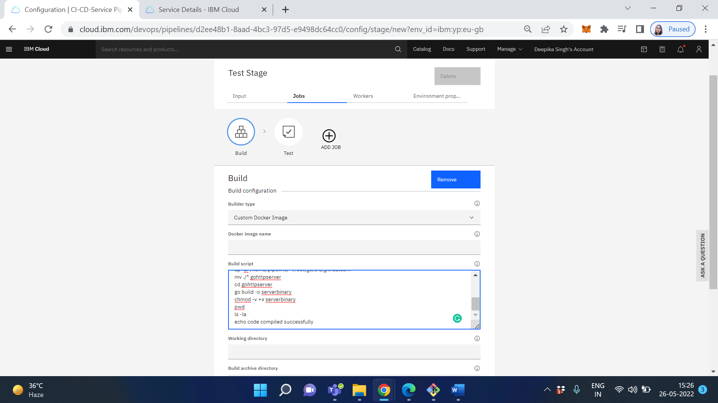

Add the following script into the build script box on the "Build" stage and modify it to suit your project. I called my directory "gohttpserver" but you can change it to be the name of your repository/project. This script just moved the code from a temporary directory on the virtual machine into the directory tree much like you would have locally on your machine. It then builds a binary to test the code compiles

#!/bin/bash

pwd

ls -la

cd $HOME

mkdir -p go/src/github.com

mkdir -p go/pkg

mkdir -p go/bin

export GOPATH=$HOME/go

export PATH=$PATH:$GOPATH/bin

cd $HOME/go/src/github.com

cp -ar /home/pipeline/* /root/go/src/github.com

mv ./* gohttpserver

cd gohttpserver

go build -o serverbinary

chmod -v +x serverbinary

pwd

ls -la

echo code compiled successfully

Move onto the "Test" stage and do the same. Copy the script from your "Build" stage and modify the end of it to look something like this

#!/bin/bash

pwd

ls -la

cd $HOME

mkdir -p go/src/github.com

mkdir -p go/pkg

mkdir -p go/bin

export GOPATH=$HOME/go

export PATH=$PATH:$GOPATH/bin

cd $HOME/go/src/github.com

cp -ar /home/pipeline/* /root/go/src/github.com

mv ./* gohttpserver

cd gohttpserver

go test ./...

echo test run successful

This is just running the tests within the repository and not building a binary

That is the Build/Test stage complete, now we need to create the deploy stage. This stage will run when the pull request is merged into the main/master branch

Go back to the stages overview and clone the first stage we created by clicking the cog on the stage and selecting "Clone stage"

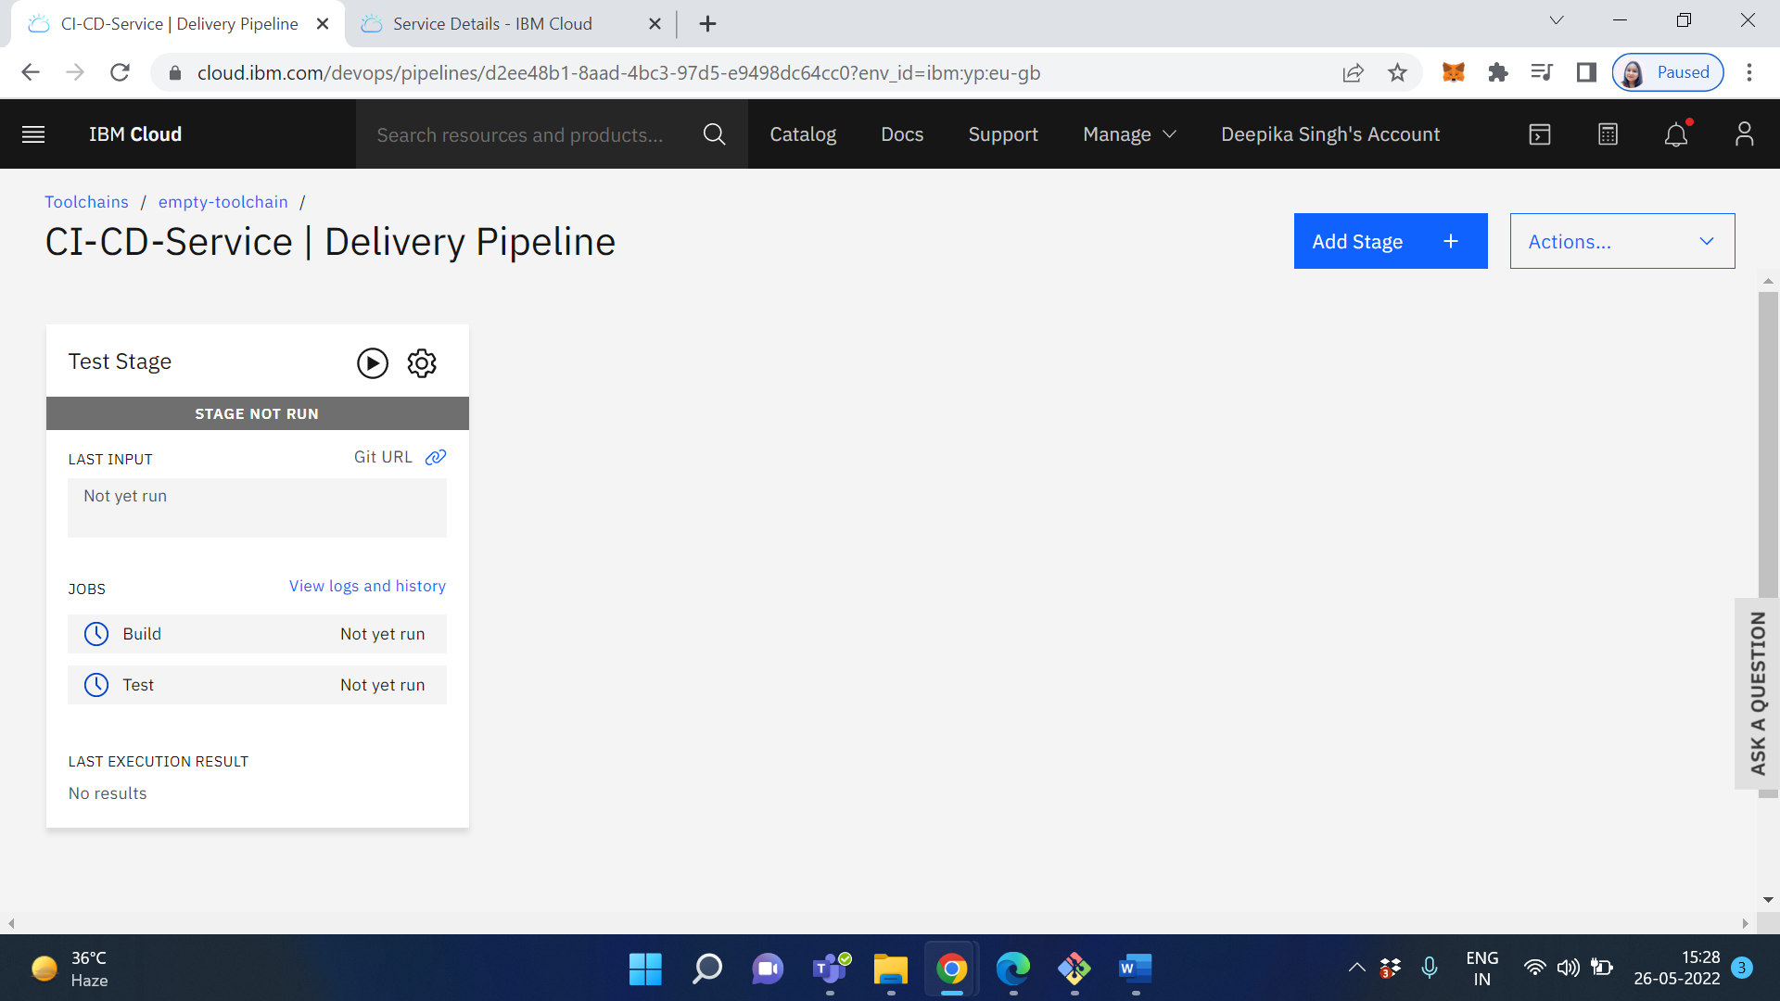

Click on Stage Configuration

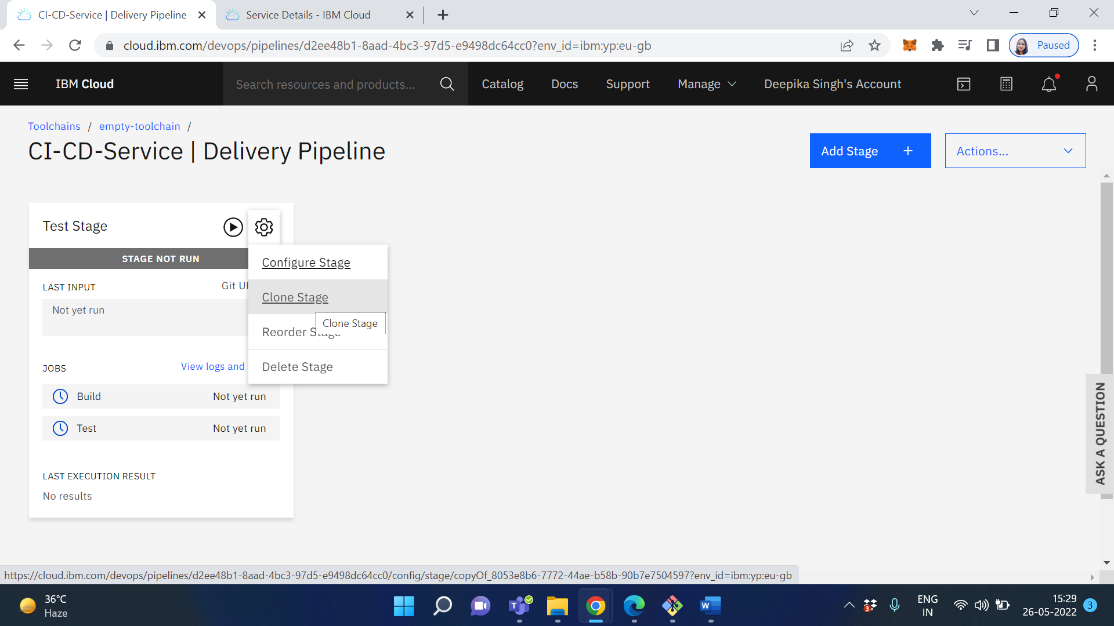

Click on Stage clone

Then rename it to "Deploy" and we want this stage to be triggered by a new commit into the master/main branch and not on a new pull request. On the "Input" tab, check the box "When a commit is pushed"

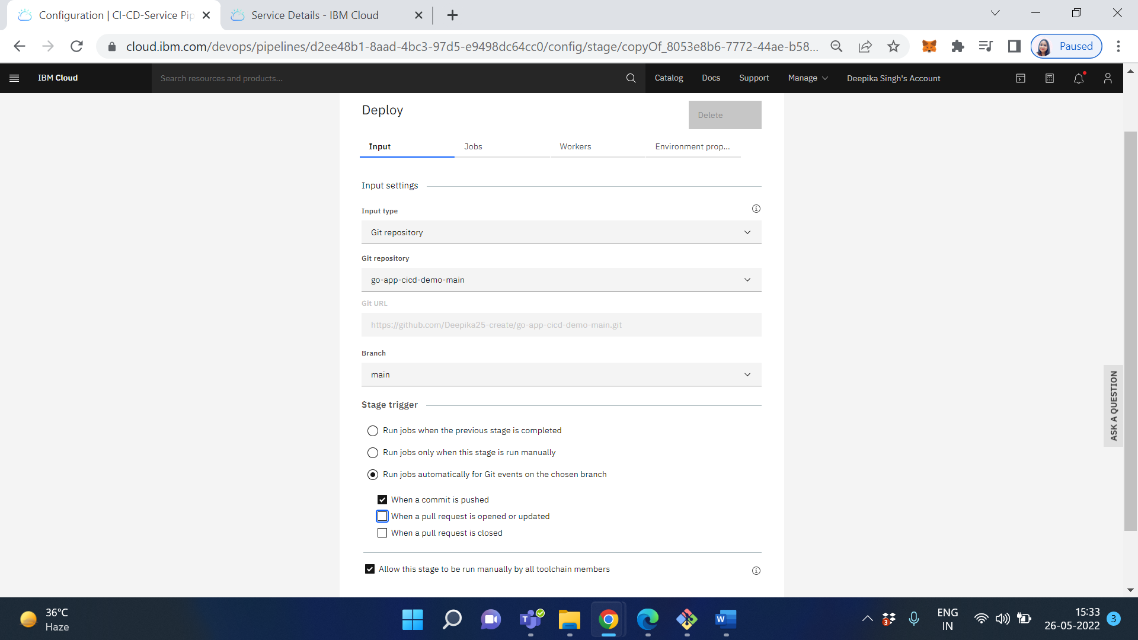

On the "Jobs" section, add a new "Deploy" job and fill out the details for your project. You want to make sure the deployer type is Cloud Foundry (you can choose Kubernetes if you wish but the setup will be different). You will also need to create a new API key for the integration to work (shown below)

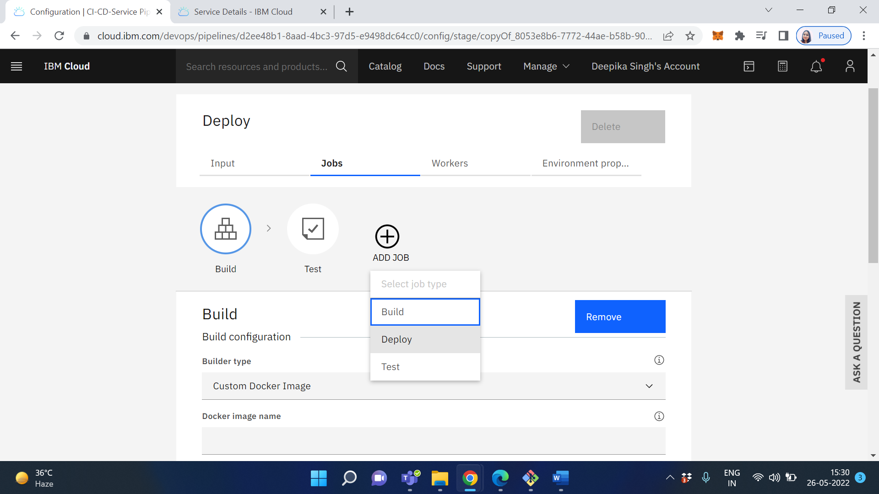

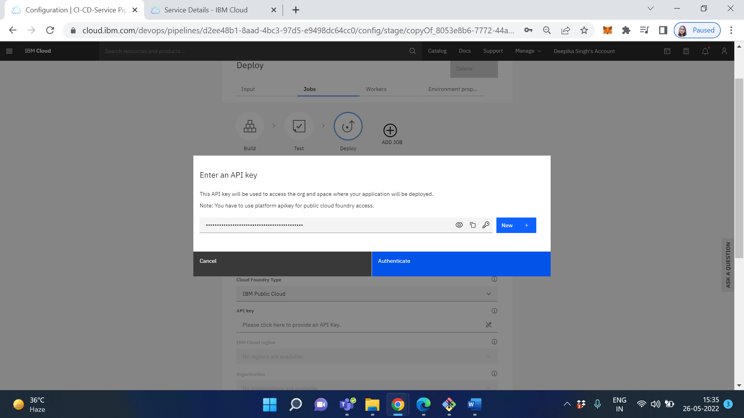

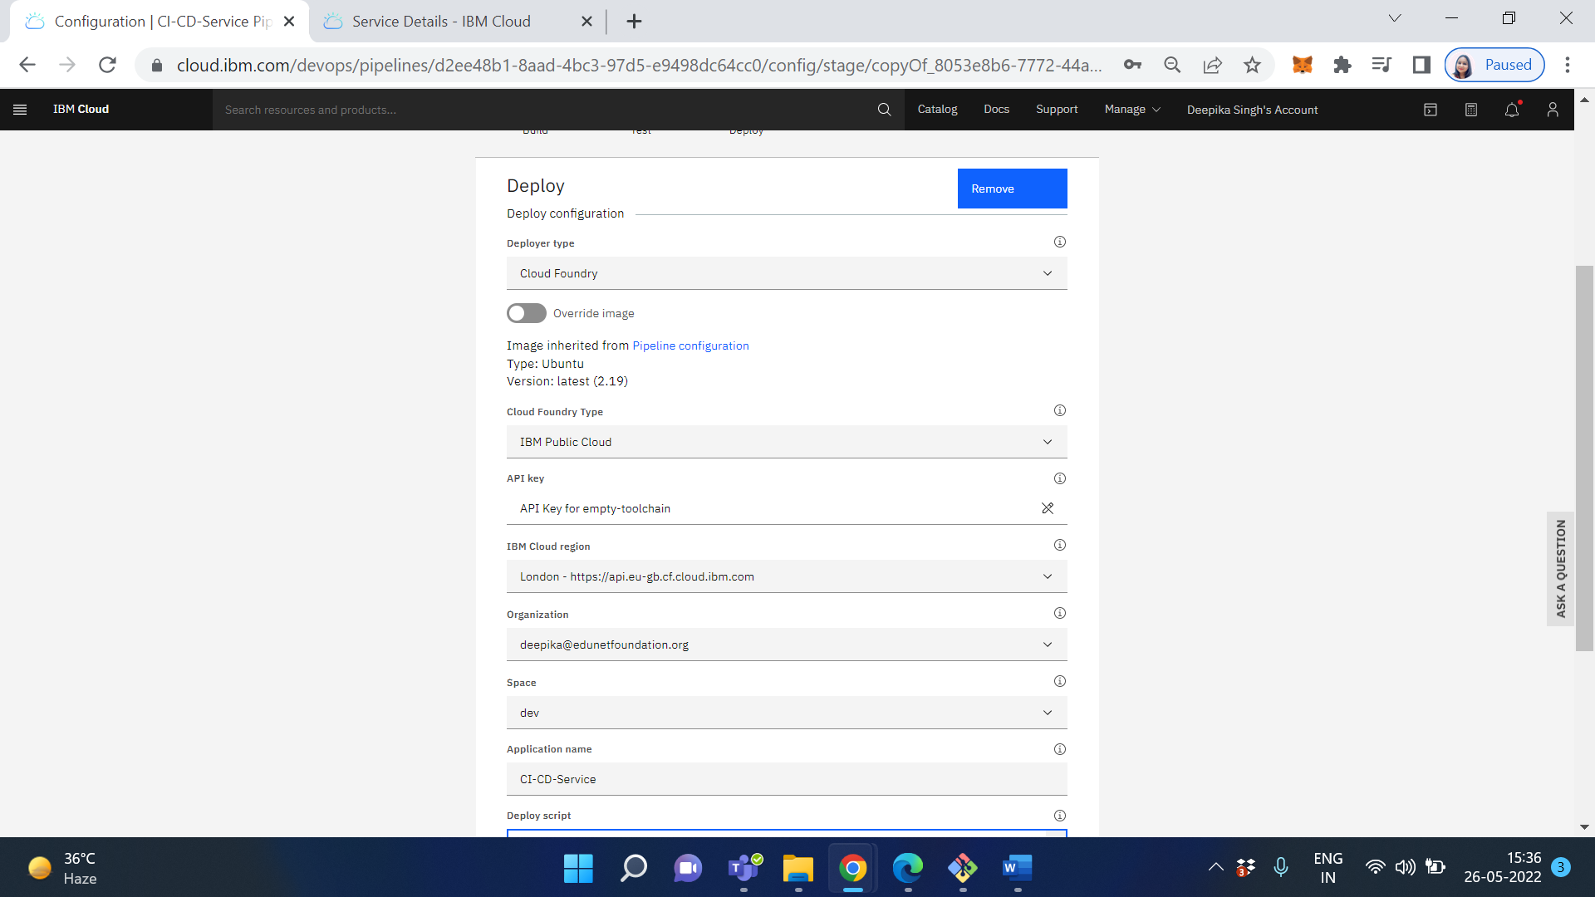

Make sure the region selected is the same as your toolchain and the application name is the same as your pipeline. The script is very simple and should be pre-populated for you. Once completed, save and exit.

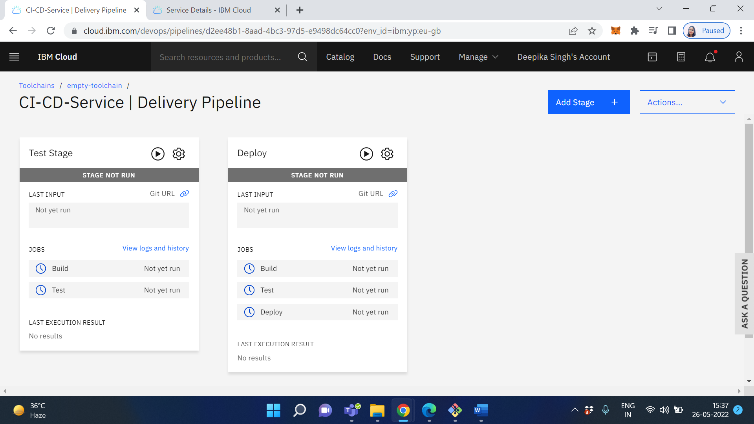

Your toolchain is now set up!

Next go to your github repository, change the test file main_test.go

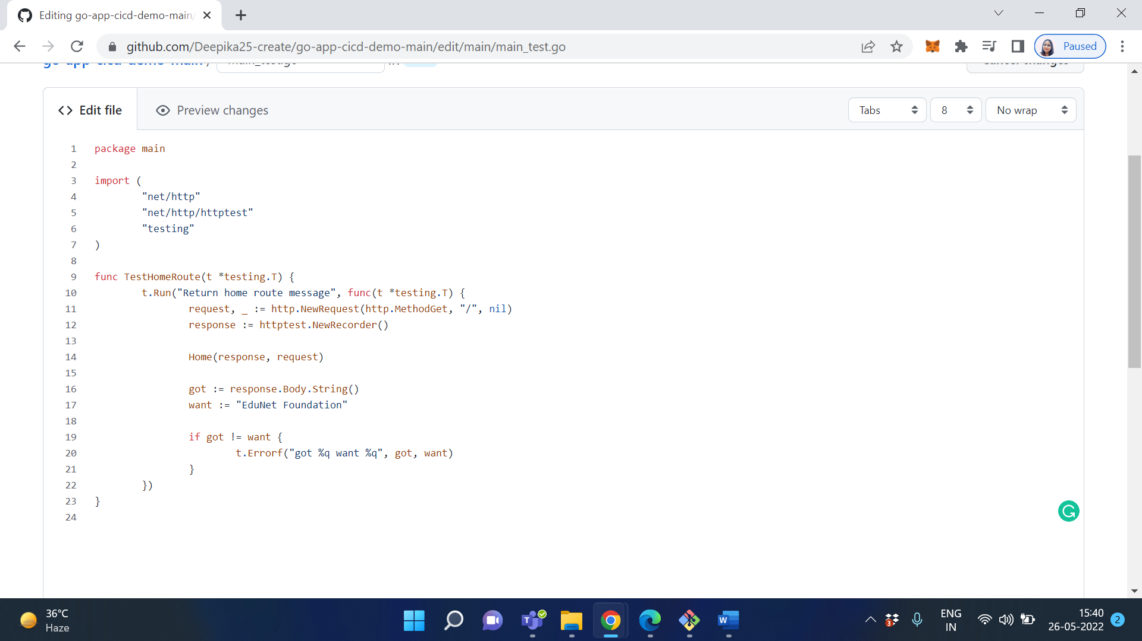

Click on Save, commit changes

And then change the corresponding code in main.go

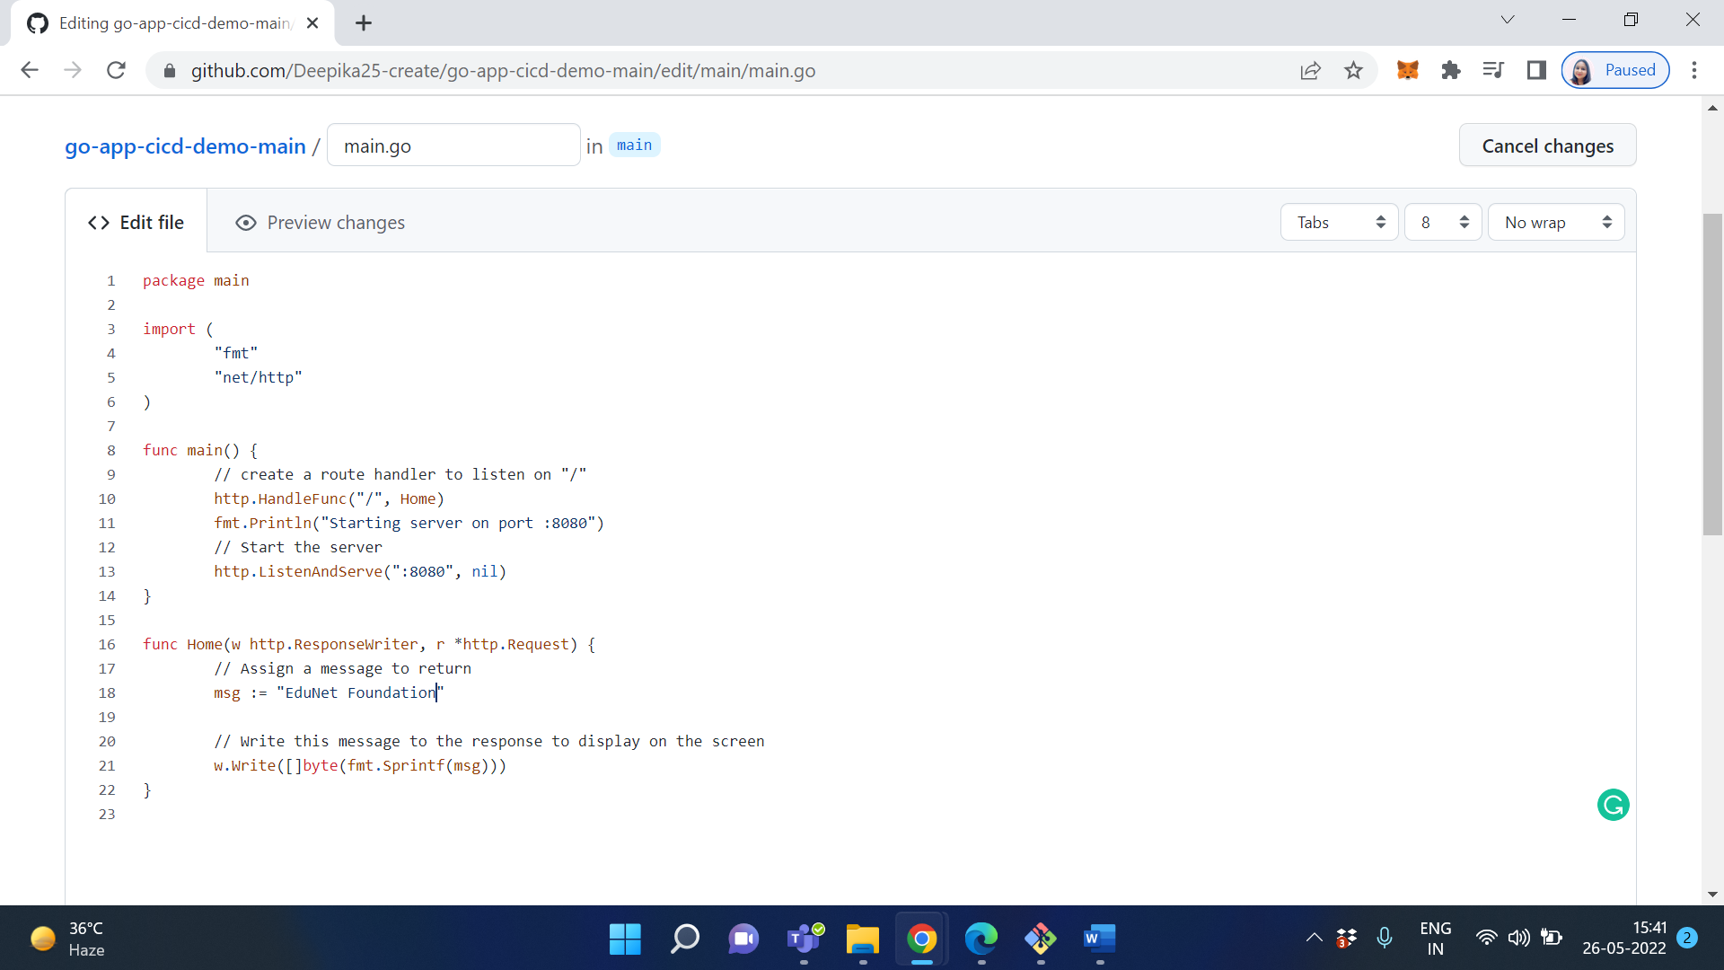

Click on Save, commit changes

Once the test stage has finished, you will be able to merge the pull request. Go ahead and merge it. Then check the toolchain and you will see

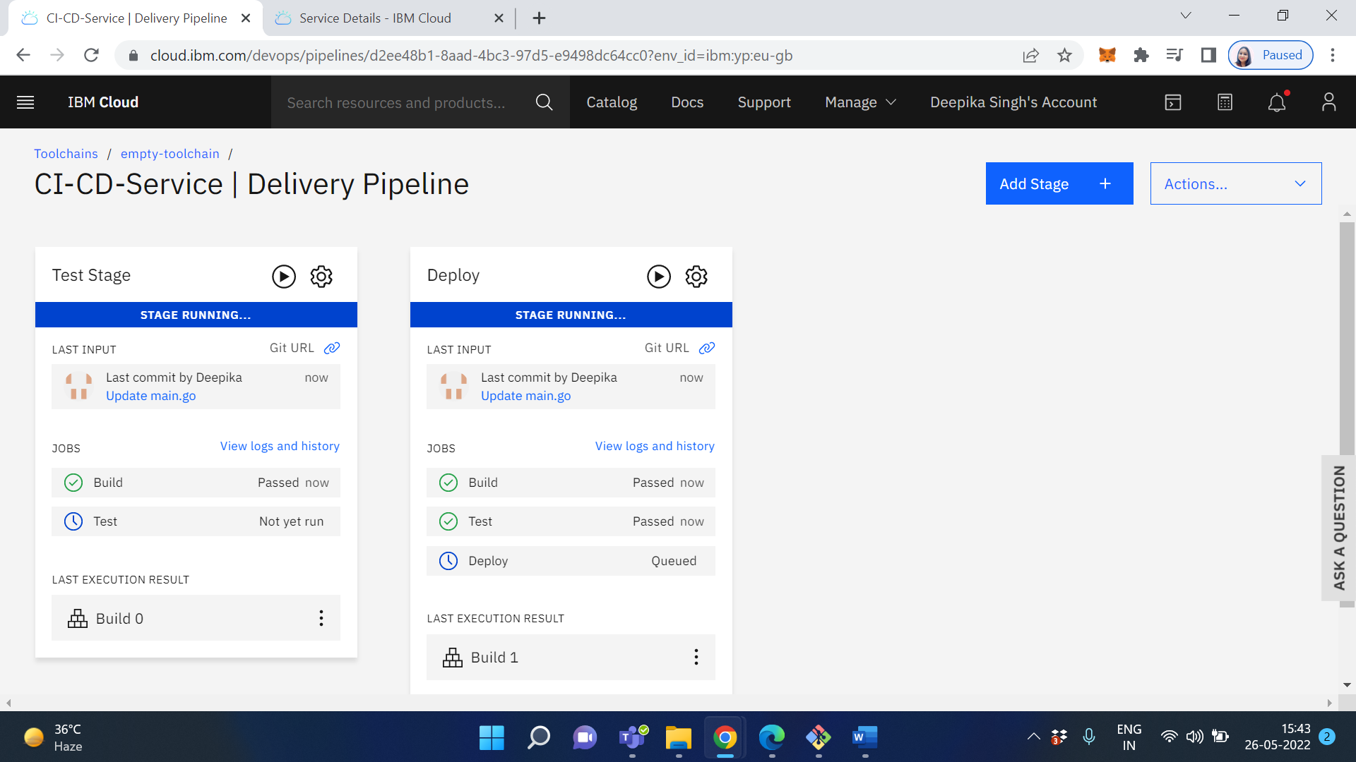

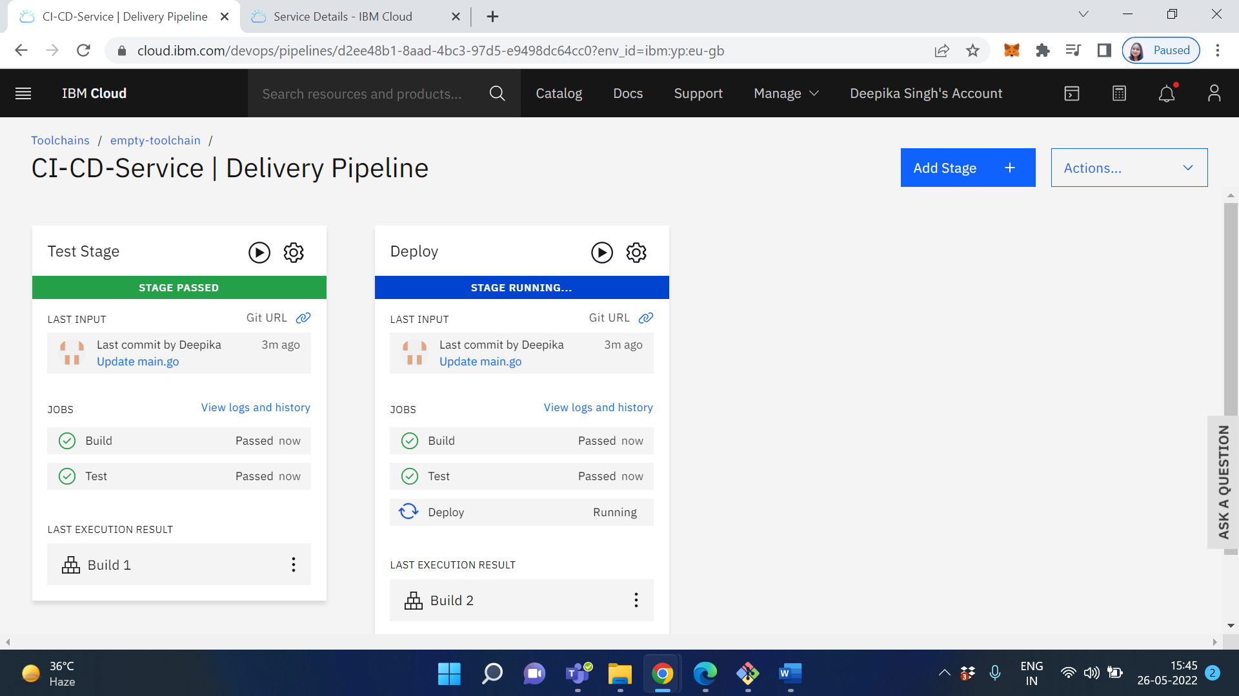

Once the build stage has finished, click on the link "View logs and history". Scroll to the bottom and you will see the result of the build and where it is deployed in Cloud Foundry. Navigate to the route in a browser and you will see your app running

**Output/Results snippet:**

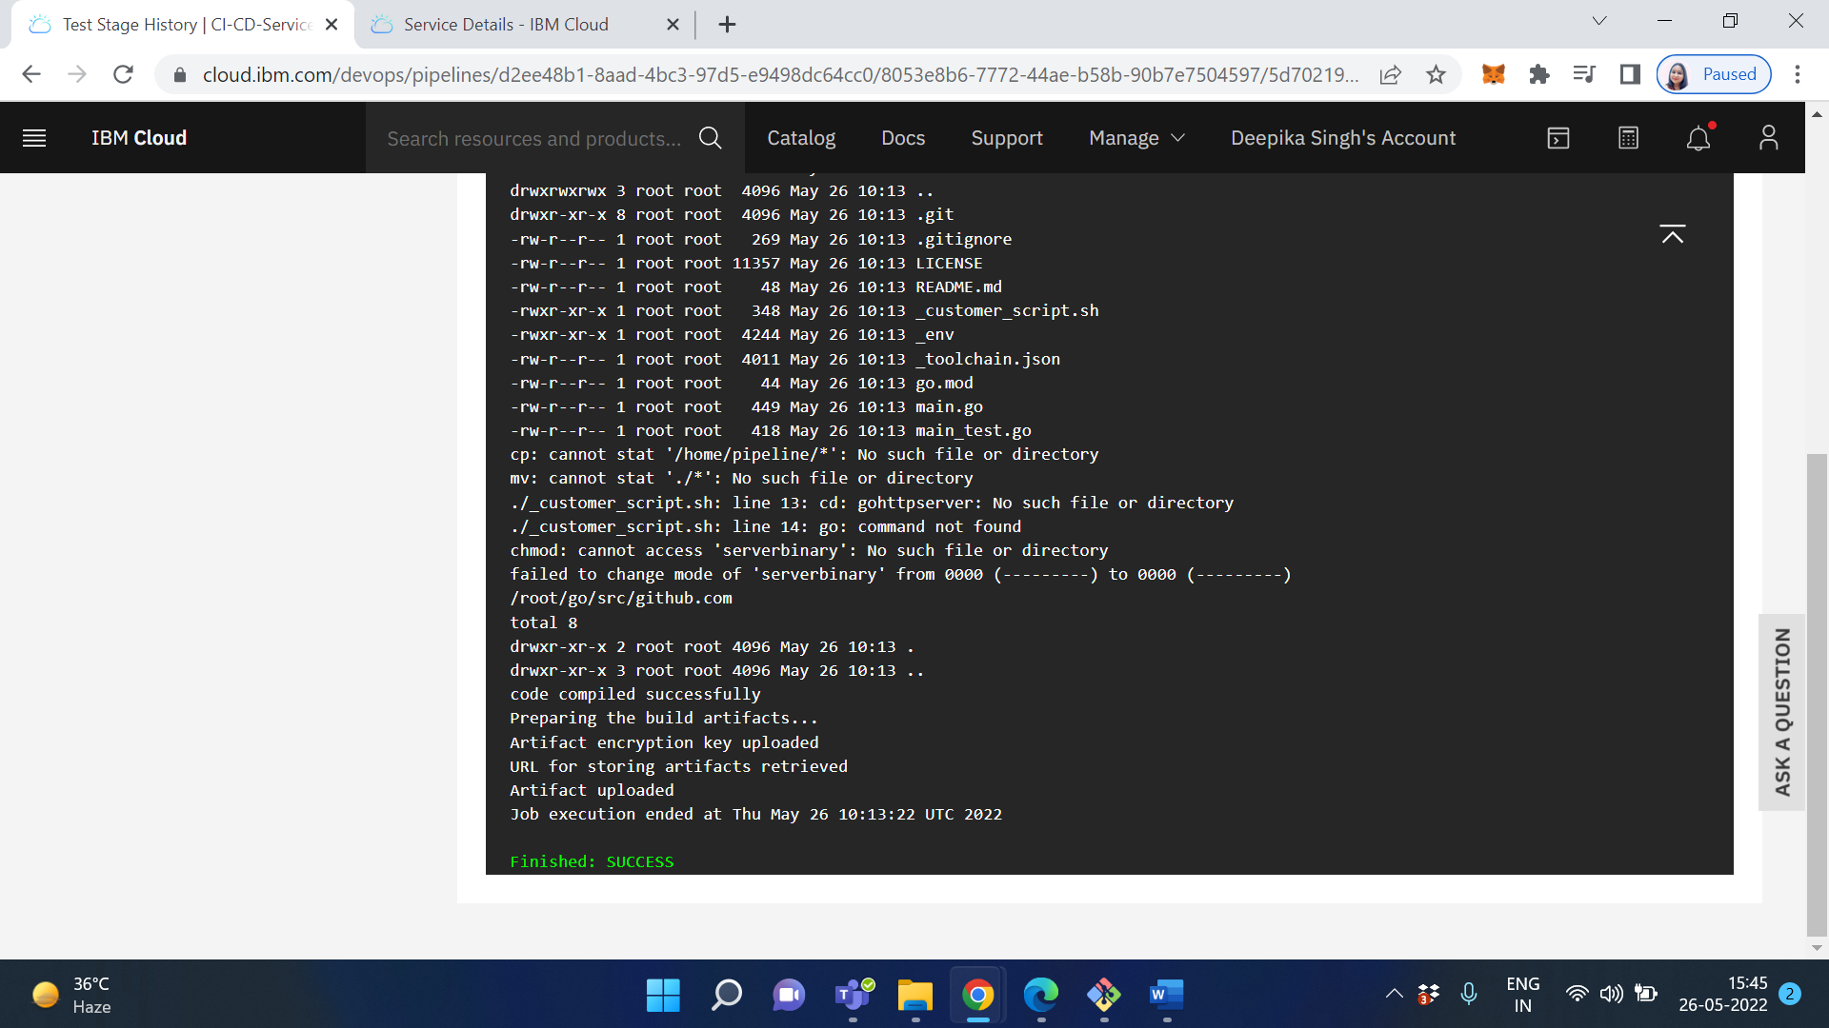

**References:**

1. <https://www.ibm.com/cloud/architecture/tutorials/introduce-develop-cloud-foundry-app-toolchain/>
2. <https://www.c-sharpcorner.com/article/set-up-continuous-deployment-pipeline-for-cloud-foundry-application-us/>
3. <https://www.c-sharpcorner.com/article/set-up-continuous-deployment-pipeline-for-cloud-foundry-application-us/>